Addy's Gift Shop Sizzling Summer Sale

Released on: June 17, 2008, 8:24 pm
Press Release Author: Delores Henriques
Industry: Retail
Press Release Summary: Addy's Gift Shop Online has launched its Summer Sale cutting prices by a whopping 40%

Press Release Body: Addy's Gift Shop Online is turning up the heat for a sizzling Summer treat. Addysgiftshop.com is giving a 40% discount on all purchases. This online store offers a wide range of Home and Garden decor from Table fountains to Garden fountains, Figurines of all kinds superbly crafted to highlight each charming beauty. Wall plaques, vases of all styles and sizes, the most attractive scented candles and unique candle holders are all available for the most reasonable prices.
We have Wooden Benches, Chairs Swings and Bird Houses of the highest quality. If you are at all serious about making your Home and Garden stand out in posh elegance Addysgiftshop.com is the place to go.
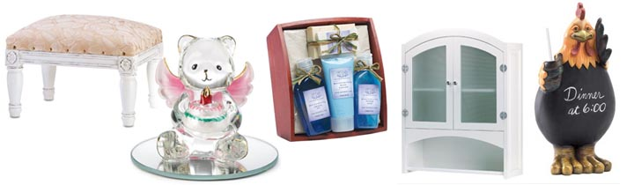
To add a touch of elegance to your bathroom, we have furniture pieces of simple sophistication to suit your need. For your kitchen we have tableware and silverware and wall plaques to spice up your kitchen with bright bold colors.
Addy's Gift Shop has gifts for all occasions for everyone in the family, Bath and Body, watches, Expressions of Love etc. Whether you need to shop for your individual needs or to purchase merchandize for your Gift Shops, Addy's Gift Shop has it all. Special prices are available for those who wish to purchase for their shops.
We also have catalogs that feature our Online merchandize and much more. Getting our catalog is very important. You may email us or call for a catalog which will sent to you free of cost.
Log on to Addysgiftshop.com today and enjoy the savings. Check us out Now!
Web Site: http://addysgiftshop.com
Contact Details: 2012 Derbyshire Drive
Macon GA, 31216
Phone:478-784-3481
Fax: 478-784-3481
Email:henriquesdel@bellsouth.net

