Ludowici Roof Tile Introduces Innovative And Affordable Slate Alternative


Released on: July 31, 2008, 7:25 am
Press Release Author: Teresa Spencer/Ludowici Roof Tile
Industry: Construction
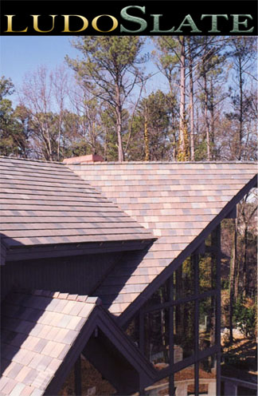
Press Release Summary: New LudoSlate™ Line Meets Consumer Need For A Slate Alternative That Will Not Curl Or Fade Over Time
Press Release Body: Driven by customer demand, Ludowici has introduced a new offering that combines the advantages of natural clay and the beauty and aesthetics of slate.
Ludowici engineers have designed an innovative product that is lightweight (less than 600 lbs per square), fully walkable (with a breaking strength of over 400 lbs), and has all the beauty and color of traditional slate at a cost that is competitive with less dependable, mass market composite products, but with the added benefit of a 75 year warranty from a company that has been in operation in the United States for 120 years!
The color range for LudoSlate™ is the broadest on the market—a broad array of colors and blends that cover all of the classical ranges of slate, but unlike mined slate, LudoSlate™ will be able to consistently repeat the colors over time. In addition, the LudoSlate™ line includes LudoSlate Premier™ with varied widths available for those that prefer a more random appearance.
About Ludowici: Ludowici Roof Tile is an American based manufacturer located in southeastern Ohio that has been in continuous operation since 1888 mining rich Ohio clays to manufacture a wide variety of top of the line clay roof products.
###
If you’d like more information about this product, please call Becky Antle at 800/917-8998 or email info@ludowici.com.
Web Site: http://www.ludowici.com
Contact Details: Ludowici Roof Tile
4757 Tile Plant Rd.
New Lexington, OH 43764
info@ludowici.com
800 917 8998

