Radicomm Announces Push-To-Talk Over Wi-Fi for Motorola Warehouse Devices

Released on: July 20, 2008, 5:45 pm
Press Release Author: Joseph C. Rattz, Jr.
Industry: Telecommunications
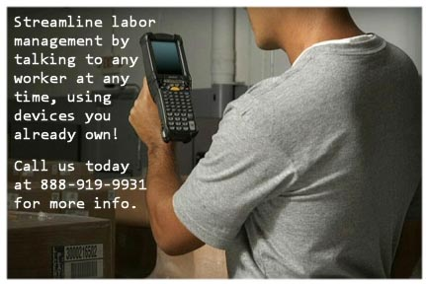
Press Release Summary: Radicomm, Inc., a Motorola PartnerSelect ISV, has released QuickTalk, a voice communication system for rugged mobile scanning devices.
Press Release Body: Radicomm, Inc., a Motorola PartnerSelect ISV (Independent Software Vendor), has released QuickTalk, a voice communication system for rugged mobile scanning devices like the Motorola MC9090 and MC70. Using QuickTalk, stockroom managers and other supervisors can talk to any worker in their warehouse, factory, or distribution center with the push of a button. All voice communication takes place over the worker's scanning device, but because of QuickTalk's seamless design the worker never has to leave his current application to talk back.
"Other vendors tend to only target supervisor PDAs like the MC70. Of course we support those devices too, but running QuickTalk seamlessly on an MC9090 is where Radicomm really separates itself from the competition," explains Brad Radaker, founder and CEO of Radicomm.
QuickTalk is a complete warehouse communication system that not only allows supervisors to call out to their workers, but also allows workers to directly contact their supervisors if that's what the company desires. Using the QuickTalk Administrator program, organizations can create Role Visibility Relationships to define who is allowed to contact whom within each site. Site Trust Relationships may also be created to enable managers in one site to contact their counterparts in another site.
A fully functional 30 day trial of QuickTalk is available from the Radicomm web site at www.radicomm.com. For more information please call 1-888-919-9931 or email sales@radicomm.com.
###
About Radicomm
Radicomm creates user-friendly software for the warehouse environment. Our mission is to provide straightforward, cost effective solutions for organizations looking to unlock the true potential of the automated warehouse. For more information please call 1-888-919-9931, or visit our website at www.radicomm.com.
Web Site: http://www.radicomm.com
Contact Details: Radicomm, Inc.
5120 Hyatt Drive NW
Suite 200
Acworth, GA 30101-4585
888-919-9931
sales@radicomm.com

