Machinery Movers - Machine Storage - Riggers - Millwrights - Heavy Haulers - Machinery Installers
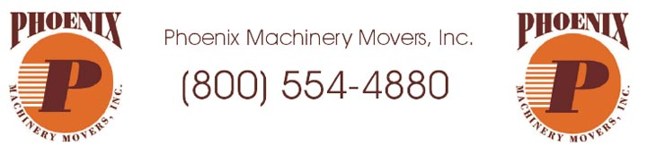
Released on: August 20, 2008, 12:42 am
Press Release Author: Phoenix Machinery Movers
Industry: Industrial
Press Release Summary: Phoenix Machinery Movers wants to add your organization to our long list of satisfied customers! We are eager to demonstrate our professional skills while giving attention to your machinery moving needs. Visit our website for a professional quote.
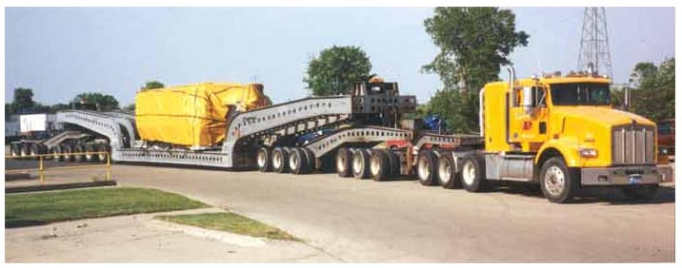
Press Release Body: Phoenix Machinery Movers knows the benefits of having the right tools for the job in the machinery moving industry. The right tools go beyond trucks, cranes, lift trucks and specialized moving equipment. Experience may be the most important asset in the industry and you can be confident that our employees have the "on the job" rigging know-how. We are continually upgrading and training our employees' skills. At Phoenix, we know that the future depends on our investment in people.
Our heavy machinery experience has awarded us with an excellent reputation throughout the heavy hauling industry. Whether you need a machine moved within your plant, or you are relocating your entire plant across the country, our machinery experts are prepared for the challenge. Our project leaders not only manage the removal, transportation, and setup of your machines, but they also ensure the timely construction of your new plant including the proper foundations & pits. We provide turnkey solutions in mechanical, electrical, piping (hydraulic, air, & water), rigging, millwright services, machinery moving & heavy hauling.
Phoenix Machinery Movers maintains its high standards by keeping up-to-date with machinery manufactures’ specifications. We are authorized installers for many of the well known machine builders. Rest assured that your project is in good hands with one of the few manufacturer recommended machinery installers. Our personnel can disassemble, package, haul, and reassemble your machines based on the manufacturers’ specifications. At Phoenix Machinery Movers our employees meet or exceed both MUST and OSHA 30 Certifications.
We pride ourselves with our investment in heavy hauling & machinery moving equipment. We employ an entire team of qualified mechanics. Our safety records prove our commitment to excellence. Proper maintenance not only ensures safety, but also minimizes any downtime that may result in unnecessary repairs.
Our machinery moving services are not geographically limited to just the U.S. We have experience with our heavy hauling equipment in both Mexico and Canada. We also partner with other highly qualified machine rigging companies worldwide. Phoenix Machinery Movers is well established with several international shipping lines. We are prepared for your overseas crating, packaging and shipping. Let our experienced professionals deal with the red tape that comes along with customs and international brokerage.
For more information or to request a quote, please visit our website. http://www.phoenixmachinerymovers.com

Web Site: http://www.phoenixmachinerymovers.com
Contact Details: Phoenix Machinery Movers, Inc.
50555 Corporate Drive
Shelby Twp., MI 48315
(586) 731-9100 (800) 554-4880
http://www.phoenixmachinerymovers.com

