Out West: Biomass Energy Curbs Wildfires, Reduces Heating Cost
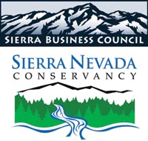
Released on: September 16, 2008, 9:20 am
Press Release Author: Velocity7 Communications
Industry: Environment
Press Release Summary: Fuels for Schools and Beyond is a recognized national leader in community biomass projects, moving into providing biomass energy for schools and private enterprise while maintaining healthy forests.
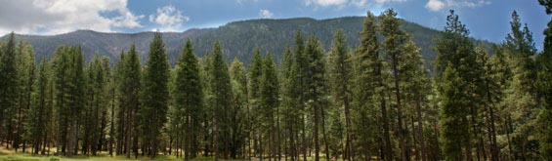
The Fuels for Schools and Beyond program is a partnership between the USDA Forest Service’s State & Private Forestry Division, the State Foresters of Montana, North Dakota, Idaho, Nevada, Utah and Wyoming, and the Bitter Root Resource Conservation and Development (RC&D) Area, Inc., to promote and facilitate the use of forest biomass waste for heating, cooling and power in public and private buildings.
These organizations are advancing local and national policies in biomass utilization, and ensuring the viability of the nation’s forests and communities.
There are currently 14 biomass boilers operating throughout North Dakota, Montana, Idaho and Nevada with two more in the design or construction phase. While continuing to provide support to existing projects, the program is now actively advancing “wood to energy” for private enterprise.
Dave Atkins, Fuels for Schools and Beyond Program Manager, from Missoula Montana, is one of the presenters at Sierra Solutions conference in Mammoth Lakes, California October 3-4, 2008.
Press Release Body: After the wildfires in the summer of 2000, which burned over 350,000 acres and 70 structures in the Bitterroot Valley of Montana, a resident of Darby, Montana began to research ways in which to tie fire hazard reduction work with economic development in the valley. Discovering that waste wood was being used to heat a number of schools in the northeastern U.S., this individual approached community leaders with the idea of using slash (tree limbs, tops and branches) from hazardous fuels reduction projects for heat in Darby’s schools. With the aid of a grant from the Economic Action Program and assistance from the Bitter Root RC&D, USDA Forest Service Forest Products Laboratory and the Biomass Energy Resource Center, a biomass boiler system was planned, designed and installed at Darby and began heating three schools in the fall of 2003.
Today, Fuels for Schools and Beyond is a recognized national leader in community biomass projects, moving into providing biomass energy for schools and private enterprise while maintaining healthy forests.
The Fuels for Schools and Beyond program is a partnership between the USDA Forest Service’s State & Private Forestry Division, the State Foresters of Montana, North Dakota, Idaho, Nevada, Utah and Wyoming, and the Bitter Root Resource Conservation and Development (RC&D) Area, Inc., to promote and facilitate the use of forest biomass waste for heating, cooling and power in public and private buildings.
These organizations are advancing local and national policies in biomass utilization, and ensuring the viability of the nation’s forests and communities.
There are currently 14 biomass boilers operating throughout North Dakota, Montana, Idaho and Nevada with two more in the design or construction phase. While continuing to provide support to existing projects, the program is now actively advancing “wood to energy” for private enterprise.
Dave Atkins, Fuels for Schools and Beyond Program Manager, from Missoula Montana, is one of the presenters at Sierra Solutions conference in Mammoth Lakes, California October 3-4, 2008.
ABOUT THE CONFERENCE: SIERRA SOLUTIONS—Tools for Sustainable Communities, Economies and the Environment October 3-4, 2008 Mammoth Resort Conference Center Mammoth Lakes, CA
Hosted by The Sierra Business Council and the Sierra Nevada Conservancy, SIERRA SOLUTIONS highlights leading sustainability speakers, who believe
“The Sierra Nevada is a place that serves as a model for the rest of the nation – it is a place where we pursue a green economy, support valuable ecosystems, and design sustainable communities.” Steve Frisch, Sierra Business Council
Solution-based tools, processes and opportunities for ensuring sustainable and vibrant Sierra communities, landscapes and local economies are the focus of this 2-day event in scenic Mammoth, California.
Conference details—Nikki Streegan 530.582.4800
######
Web Site: http://www.sbcouncil.org/Events/Schedule
Contact Details: Conference details—Nikki Streegan 530.582.4800
nstreegan@sbcouncil.org
PR Details—Pamela Biery 530.470.9292
pamela@velocity7.com

