Highland Fayre Launch New Range of Hampers
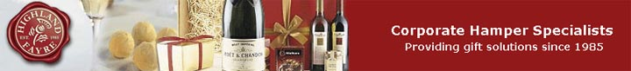

Released on: October 14, 2008, 5:38 am
Press Release Author: Highland Fayre
Industry: Food & Beverage
Press Release Summary: Highland Fayre has launched a new range of luxury hampers.

Press Release Body: Highland Fayre, the premier Scottish hamper company for luxury corporate gift hampers, has just released a brand new range of hampers.
The new Highland Fayre hamper range is set to offer a wide selection of goods, including the company's Royal Banquet, which contains a selection of their finest wines and gourmet food. There is also variety of Scottish hampers, chocolate gift boxes and the traditional port and stilton selections, as well as cases of wine and champagne hampers.
Highland Fayre is also continuing to offer customers the bespoke hamper service, as well as the new range of hampers. The service offers clients the ability to specify the contents of their hamper, as well as the style of packaging and type of delivery service. A large selection of food is on offer and hampers can also be tailored to particular food and drink types.
Highland Fayre has also recently noticed an increase in business from abroad. A spokesperson for Highland Fayrecommented on the increasing popularity of its hampers from British expats living overseas:
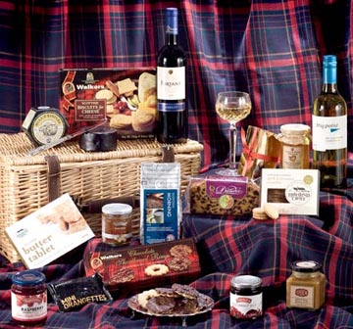
"Our hampers have always been popular with UK customers and now we’re seeing an increase in orders for our Christmas hampersfrom British expats currently residing in Australia, China, America and other countries. It can be difficult for those living aboard to arrange gifts for their friends and family back home, but the quick and easy nature of buying and sending a hamper through our website, is proving popular with many who reside abroad."
The popularity of Highland Fayre hampers abroad can be attributed to the company's ability to arrange delivery of their hampers throughout Europe, and its partner hamper companies in the USA, Australia, New Zealand and South Africa.
About Highland Fayre:
Highland Fayre Ltd is the premier Scottish hamper company for luxury corporate gift hampers. Highland Fayre was established in 1985 and has since developed a high quality reputation within the corporate gift market.
Highland Fayre extensive experience of supplying bespoke hampers and gifts allows their dedicated team to gauge instinctively which luxury items recipients most like to find in their hamper or gift box. Highland Fayre offers a selection of luxury gift hampers that includes wine gift boxes, themed hampers and luxury Christmas hampers for all ranges of budgets.
Web Site: http://www.highlandfayre.co.uk/
Contact Details:
Highland Fayre PR Contact
David England
Managing Director
Highland Fayre Ltd
Kilda Way
Perth
PH1 3XS
01738 639 222

