LA Jury Awards Quadriplegic Man $10 million in bad faith case
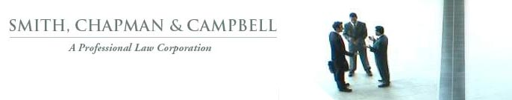

Released on: November 19, 2008, 7:29 am
Press Release Author: William D. Chapman
Industry: Law
Press Release Summary: In January 2002, Atlantic Mutual had a chance to settle a quadriplegic personal injury case for $1 million but chose to "roll the dice." The jury awarded a $16 million verdict and the injured party sued for bad faith. Today, a LA jury found that Atlantic committed bad faith.
Press Release Body: A Los Angeles jury today awarded a quadriplegic man $10 million in a bad faith case against Atlantic Mutual Insurance Company. The jury found that Atlantic Mutual acted despicably and with malice and oppression in wrongfully refusing to settle his personal injury case in 2002. Lawyers return tomorrow to deliver closing arguments in the second phase of the trial to determine whether plaintiff is entitled to $5 million in attorneys’ fees.
Web Site: http://www.smithchapman.com/
Contact Details: 1800 N. Broadway, Suite 200, Santa Ana, CA 92706,
wchapman@smithchapman.com, phone 714.689.2141.

