LG and PRADA debut the latest PRADA Phone by LG in Europe


Released on: November 268, 2008, 5:50 am
Press Release Author: LG Electronics, Inc.
Industry: Electronics
Press Release Summary: Exclusive form of sophistication and style in contemporary mobility
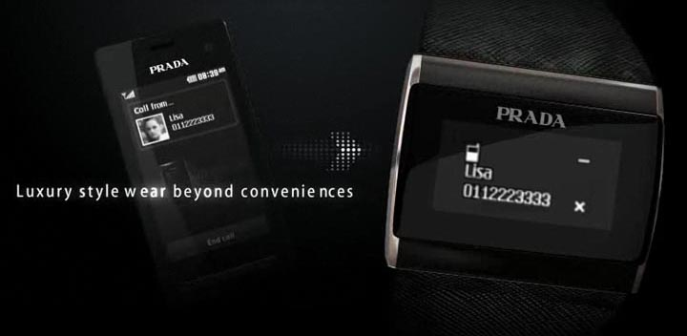
Press Release Body: London, UK, 18 November, 2008 - LG Electronics (LG), a worldwide technology and design leader in mobile communications, and PRADA, world’s leading fashion brand, today announce the global launch of the highly anticipated successor to the PRADA Phone by LG. The latest handset from LG and PRADA partnership is set to hit the stores in Europe by late November this year.
The latest edition of the PRADA Phone by LG (Model: LG-KF900) offers a collection of technical upgrades catering to today’s highest mobile needs. In the outer peripherals, new handset preserves the same original minimalist exterior that has now become a key design inspiration of touch screen handsets worldwide. A defining modification for the new handset involves a set of aesthetics keys that slide out to form a more professional look that not only grazes an elevated level of sophistication, but is also a highly efficient communication tool that complements the latest PRADA Phone by LG’s technology.
The handset’s user interface also receives a powerful improvement with LG’s latest active flash UI technology and haptic feedback on touch input enhancing the experience of the phone’s exclusive contents offerings. Dynamic upgrades to the software is well complimented by hardware extensions that include 3G capability with HSDPA up to 7.2 Mbps and advanced 5 megapixel camera featuring slow motion video recording and DivX playback. Other features include Wi-Fi, full HTML browser, and video calling capabilities.
Reinventing the most exclusive form of mobile sophistication and style, the latest version of the PRADA Phone by LG magnifies the heritage of the predecessor with exclusivePRADA elements including ring tones, wallpapers, and video clips that are carefully selected for users to fully experience the handset inside and out. Each of these unique contents displays PRADA’s extraordinary artwork dedicated to the company’s visionary design philosophy. Contents include the PRADA Fall/Winter 2008 Lookbook, newPRADA animation films dedicated to the PRADA Phone by LG, and wallpapers illustrating principal themes from PRADA’s annual design collections dating back to 2001.
This time around, LG and PRADA reinvents mobile trend with another stunning offering, the ‘PRADA Link’ (Model: LG-LBA-T950). Expected to release with the new handset, this sleek and elegantly packaged digital timepiece is a Bluetooth device that can remotely monitor phone calls as well as read full SMS text messages without having to extract the phone from a bag or pocket. Extending the handset’s luxurious exterior beyond the device itself is a new wearable type accessory; the PRADA Link not only revolutionizes the conventional methods of mobile communication, but adds practicality and convenience to a fashionable statement.
The new PRADA Phone by LG and the PRADA Link will be available with a starting price of 600 Euros and 299 Euros, respectively. The products can be purchased through major mobile dealerships in the UK, France, Germany, Italy, Spain, Netherlands, and other countries in Europe. Please contact your local operator for details on the handset’s availability in your area.
For further information, please visit www.pradaphonebylg.com
###
About LG Electronics, Inc.
LG Electronics, Inc. (KSE: 066570.KS) is a global leader and technology innovator in consumer electronics, home appliances and mobile communications, employing more than 82,000 people working in 114 operations including 82 subsidiaries around the world. With 2007 global sales of USD 44 billion, LG is comprised of four business units - Mobile Communications, Digital Appliance, Digital Display and Digital Media. LG is the world’s leading producer of mobile handsets, flat panel TVs, air conditioners, front-loading washing machines, optical storage products, DVD players and home theater systems.
LG Electronics Mobile Communications Company (LG) is a leading global mobile communication and information company. LG creates handsets that provide an optimized mobile experience to customers around the world with its cutting-edge technology and innovative handset design capabilities. Increasingly, LG is perusing convergence technology and mobile computing products. LG will continue to take leadership in the mobile communication environment with stylish designs and smart technology. For more information, please visit www.lge.com.
About PRADA Group
The PRADA Group is one of the world’s leading companies in the luxury goods market. Through the Prada, Miu Miu, Church’s and Car Shoe brands, the Group manufactures and markets high-quality handbags, leather goods and accessories, footwear, ready-to-wear, eyewear and fragrances. Its products are sold in 78 Countries around the world through 211 directly operated stores and a network of selected, high-end multi-brand shops and luxury department stores. The Group relies on 16 production plants, 14 located in Italy and 2 in Great Britain (for Church’s) and on 6,900 employees worldwide. Group’s revenues in 2007 reached 1.7 billion Euros.
Web Site: www.lge.com
Contact Details: LG Electronics:
Jun Hyuk Choi
LG Electronics
Corporate Communications
Office: +82 2 3777 3623
Email: lgpr@lge.com

