Parents Can Make Surgery Harder For Their Kids
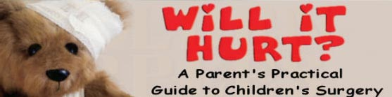

Released on: November 13, 2008, 9:17 am
Press Release Author: Arbor Books
Industry: Healthcare
Press Release Summary: Parents Can Make Surgery Harder For Their Kids
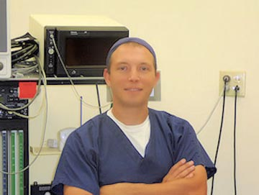
Press Release Body: (SOUTHBURY, CT)—Nearly 5 million children underwent surgery in the United States in 2008 and according to one prominent anesthesiologist, many of those surgeries were made more difficult by parents who refused to follow their doctor's orders.
Dr. Armen Ketchedjian, author of the book Will It Hurt? A Parent’s Practical Guide to Children’s Surgery, says that parents often ignore doctors' directions and requests for pre-surgery testing and preparation.
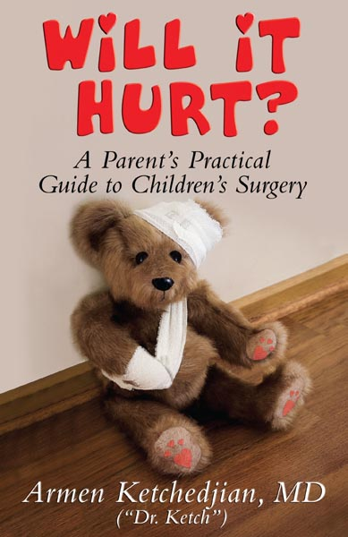
Considering the stakes, the reasons parents give for not complying with their doctor often seem, well, unreasonable: Scheduled tests may interfere with family vacation plans or because parents, in their own opinion, feel that the requested tests or
diets aren't important.
“I've seen parents who felt that the rules didn't apply to them,” says Dr. Ketch, as he is known to his patients. “They assume that doctor's will understand if certain tests are not done or if certain consultations are missed.”
Missed appointments and tests cause unnecessary delays in the preparation for surgery according to Dr. Ketch, who says that medical professionals order the tests for a reason.
“We in the medical profession are held to a higher standard and so we can't take anything for granted,” says Dr. Ketch. “We need the fullest cooperation of parents to provide the best care possible.”
Will it Hurt? is a guide for parents whose children need surgery and a big part of the book's message is the importance of the preparations that contribute to a successful surgery. Dr. Ketch says he believes that informed parents make the experience easy for everyone, including their child. And that can pay big dividends after the surgery.
According to Dr. Ketch, “Children who are less anxious need less anesthesia during surgery and less recovery time after the surgery. Parents can ensure their children are more relaxed by being informed and by not putting any undue stress on the process.”
Will It Hurt? helps educate parents about pediatric surgery. It is an easy to-read resource will give you, your child and your family the help and reassurance you need to make the surgical experience as stress-free as possible.
Listed in The Guide to America’s Top Anesthesiologists by the Consumer Research Council of America, Dr. Ketch trained at Cornell Medical Center, with a fellowship at Memorial Sloan-Kettering Cancer Center and a pain management elective at Boston Children’s Hospital. He has also worked to help develop new techniques in ambulatory anesthesia, taught medical students and residents, and cared for more than 10,000 patients.
Dr. Ketch is also the author of the children's book Golden Apples (winner of the 2008 Reviewer's Choice Award), a beautifully illustrated book that aims to help educate children about the dangers of drug abuse.
For more information, contact the author directly at support@dr.ketch.com.
WARREN ENTERPRISES, LLC and author Dr. Armen G. Ketchedjian chose Arbor Books, Inc. (www.ArborBooks.com) to design and promote Will It Hurt? Parent’s Practical Guide to Children’s Surgery. Arbor Books is an internationally renowned, full-service book design, ghostwriting and marketing firm.
(Will It Hurt? Parent’s Practical Guide to Children’s Surgery by Dr. Ketch; ISBN: 0-9815373-0-8; $14.95; 172 pages; 5½” x 8 ½”; soft cover book with illustrations; WARREN ENTERPRISES, LLC)
Web Site: http://www.drketch.com
Contact Details: Warren Enterprises LLC
PO Box 547, Southbury, CT 06488
Contact: Armen G. Ketchedjian, MD
Phone: 203-304-2419
E-mail: support@dr.ketch.com

