Jumeirah Group and Shun Tak sign management agreement for Macau hotel
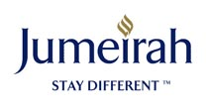

Released on: December 8, 2008, 9:30 am
Press Release Author: Jumeirah Group
Industry: Management
Press Release Summary: Jumeirah Group has signed a management agreement with Shun Tak Holdings Limited to operate its newest five star hotel in Macau
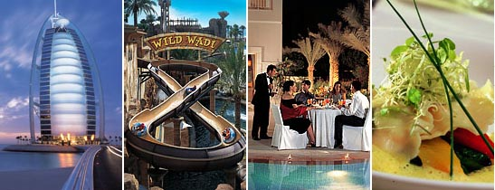
Press Release Body: Jumeriah Group, the Dubai based luxury hotel management company and member of Dubai Holding, has signed a management agreement with Shun Tak Holdings Limited which will have Jumeirah operating a new luxury hotel in the Cotai area of Macau, a region of China.
The new agreement was announced by Ms. Pansy Ho, Managing Director of Shun Tak and Mr Gerald Lawless, Executive Chairman of Jumeirah Group, at a signing ceremony held in Hong Kong.
The Jumeirah Macau Hotel, scheduled for completion in 2013, will set a new standard for luxury hotel and hospitality services in the Chinese enclave when it emerges as a leading tourism and convention hub in the region. Strategically located amid the tourism epicentre of Cotai, the new Jumeirah hotel will enjoy a spectacular view of the Macau Dome, where the city's major sports and cultural entertainment events are hosted.
"As the forerunner to introduce premium international hotels brands in Macau, we are once again ready to commit to investing in more diversified products as part of our dedicated blueprint in contributing to the city's tourism industry," said Ms. Pansy Ho. "Indeed, this major project came about at a time when some market players are uncertain about the future. Shun Tak's view of the Macau economy is long term. We remain positive that its fundamental is strong and sound, and (we) will continue to invest in its future, trusting that it will be one of the first destinations to recover from the recent market adjustments."
Speaking on the new agreement struck with Jumeirah Group, Ms. Ho commented: "Internationally acclaimed for its capability and proven track record to operate and manage an enviable portfolio of high end luxury hotels around the globe, this partnership (with Jumeirah Group) is instrumental to Shun Tak's strategy of establishing a strong foothold and market presence in the hotel and hospitality industries in the long run."
Gerald Lawless, executive chairman of Jumeirah, said: "Jumeirah is recognised as one of the leading luxury international hotel brands, and is known for being the operator of the world famous Burj Al Arab, regarded as the world's most luxurious hotel. This is the third management agreement that we have signed in China, with the first Jumeirah HanTang Xintiandi scheduled to open in Shanghai in 2009 and Jumeirah Guangzhou Hotel in 2011. We look forward to working with Shun Tak and to the opening of the Jumeirah Macau Hotel."
The Shun Tak Group owns a portfolio of valuable hotel properties in Macau, including two of the first international hotel labels in the enclave, with a third to be launched as part of its One Central development. In 2008, with the scheduled completion of a new airport hotel adjacent to the Hong Kong International Airport, Shun Tak will enter the Hong Kong hotel market for the first time, a vital step to complement its strategic tourism and hospitality services network in the up and coming travel hub in Chek Lap Kok, Hong Kong.
About Jumeirah:
Jumeirah properties are regarded as among the most luxurious and innovative in the world and have won numerous international travel and tourism awards. The fast growing Dubai based luxury international hospitality group encompasses the world renowned Burj Al Arab, the world's most luxurious hotel, the multi-award winning Jumeirah Beach Hotel, Jumeirah Emirates Towers, Madinat Jumeirah and Jumeirah Bab Al Shams Desert Resort & Spa in Dubai, the Jumeirah Carlton Tower and Jumeirah Lowndes Hotel in London and the Jumeirah Essex House Hotel in New York.
Web Site: http://www.jumeirah.com/
Contact Details: PR Contact:
Genevieve Picard
Corporate Communications Manager
Jumeirah Group Corporate Communications
PO Box 214159
Dubai
United Arab Emirates
Tel: +971 4 364 7947
Fax: +971 4 301 6655

