Republican 9/11 Hero Looks For Obama’s Help

Released on: December 23, 2008, 4:47 pm
Press Release Author: Arbor Books
Industry: Government
Press Release Summary: REPUBLICAN 9/11 HERO LOOKS FOR OBAMA’S HELP
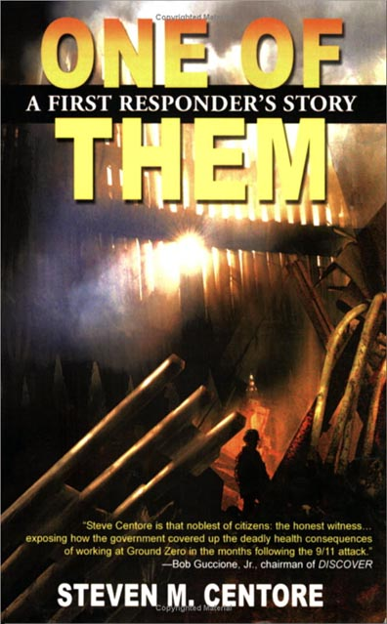
Press Release Body: (NEW BERN, NC)—One of the first responders who helped clear debris and search for bodies at the World Trade Center site is hoping President-elect Barack Obama doesn’t repeat the mistakes made by the Bush administration in handling the care of his fellow volunteers.
Steven Centore, a nuclear physicist and Navy veteran, was one of the many volunteers who assisted in the immediate aftermath of the September 11, 2001 attack.
Unfortunately, as do many of the other rescue workers, Mr. Centore now suffers from post-traumatic stress disorder and other medically debilitating ailments that have kept him from working. These conditions have required endless surgeries and physical therapy to treat.
In his book, One of Them: A First Responder’s Story, Mr. Centore details the neglect and mistreatment he and his fellow volunteers have suffered at the hands of the government.
“The Bush administration really fumbled this issue,” says Mr. Centore, a lifelong Republican. “The attacks of that day are still having an effect on this country in the wars we fight overseas. But they’re also having an effect here at home.”
Mr. Centore spent months at the World Trade Center and says that exposure to the toxins in the air at the site have crippled or killed thousands of first responders. His book includes some shocking statistics about the health of first responders, including:
• 4,517 people with upper respiratory ailments
• 3,857 with lower respiratory illness
• 398 with lung disease
• 2,616 with asthma
• 1,340 with sleep apnea
• 2,528 with heart conditions caused or worsened by 9/11
“I was appalled at the lack of support and meager financial resources provided to 9/11 first responders by the US government,” says Mr. Centore, who has testified before Congress about the thousands of people just like him who were told that the air at the WTC site was not dangerous.
He adds, “I wanted to tell the story of how I became ill, what the government did and did not do for me, and what happened to me as a result. I’d like to shed some light on the cover-ups that the government has been perpetrating in the news.”
To learn more about how you can help, or to buy the breakout book One of Them: A First Responder’s Story, visit www.SteveCentore.com or www.wadv-oneofthem.com. The book is also available on Borders.com, Amazon.com and BarnesandNoble.com.
For more information about One of Them: A First Responder’s Story, contact Steve Centore directly at Scentore@yahoo.com.
WORLDWIDE ASSOCIATION OF DISABLED VETERANS, INC. and author Steven Centore chose Arbor Books, Inc. (www.ArborBooks.com) to design and promote One of Them: A First Responder’s Story. Arbor Books is an internationally renowned, full-service book design, ghostwriting and marketing firm.
(One of Them: A First Responder’s Story by Steven M. Centore; ISBN: 0-9801274-0-8; $16.95; 208 pages; 5½”x 8½”; softcover; Worldwide Association of Disabled Veterans, Inc.)
Web Site: http://www.wadv-oneofthem.com
Contact Details: WORLDWIDE ASSOCIATION OF DISABLED VETERANS, INC.
500 Blackledge Circle, New Bern, NC 28562
Contact: Steven Centore Phone: (252)638-4790
E-mail: Scentore@yahoo.com
www.SteveCentore.com or www.wadv-oneofthem.com

