A natural Sober Up Drink, considered as the best, is finally available in the U.S.A.
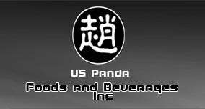
Released on: February 23, 2009, 9:03 pm
Author: Diana
Industry: Food & Beverage
“World Panda Healthy Herbal Drink” (Panda Sober Drink), a very inspirational Sober-up product, is Dr. Chao’s own patented product that comes from a line of 130-year-old formulas developed and first used by Dr. Chao’s ancestors back in 1878. This 100% all-natural herbal beverage is manufactured in the state of Wisconsin, and has been certified by the National Food Laboratory of America to be sugar-free, calorie-free, caffeine-free, contains no preservatives and no artificial sweeteners of any kind.
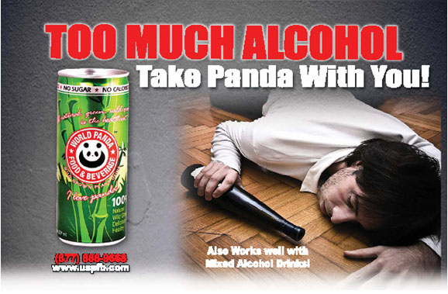
Consuming alcohol may cause headache, nausea, vomiting, dizziness, unclear mind, uncomfortable stomach, thirstiness, and a bitter taste, and can also cause severe headache, stomach ache, loss of appetite, and a lethargic feeling from a previous night of alcohol consumption.
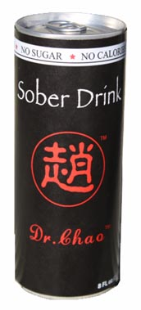
Drinking 1 to 3 cans of Panda Drink before consuming alcohol, or mixing it with alcohol, will allow individuals to drink three times more alcohol without getting drunk and dizzy.
When drunk, drinking 3 to 5 cans of Panda Drinkwill allow individuals to quickly recover from alcohol intoxication within three hours, relieving the symptoms of headache, dizziness, vomiting, thirstiness, and clearing the bitter taste, as well as avoiding a severe headache the next day. This drink enables the individual to restore his or her natural state of mind, so that they can function normally the next day.

The herbs in the Panda Drink contain special enzymes that help alcohol dehydrogenase break down alcohol quicker, then quickly convert the alcohol to harmless water and carbon dioxide and thus can be discharged rapidly through urine. At the same time, the herbs of Panda Drink help to balance the functions of the liver and the heart, improve the metabolism of cerebrum cells, and increase the cells’ absorption rate of oxygen. According to Dr.Chao’s expertise, people can avoid the harm from alcohol and won’t get drunk if alcohol can be converted into harmless water and carbon dioxide quickly. Therefore, drinking with Panda Drink will help people keep a clear head even when drinking great quantities of alcohol.
In order to expand our service, we are looking for business partner who has the financial capability and sales experience in the beverage industry to join the company’s management team.
For more information on the sober up drink, and to purchase it, please call U.S. PANDA FOODS & BEVERAGES INC. at 1-877-237-2426.
Contact: Jane Zheng at 909-625-6668
U.S. PANDA FOODS & BEVERAGES INC.
Email: Janezheng@uspfb.com
Website: www.uspfb.com

