Contemporary Mosaic Art Gallery Represents Ten of the Finest Mosaic Artists in the World
Released on: February 16, 2009, 1:24 am
Author: Pam Givens
Industry: Entertainment
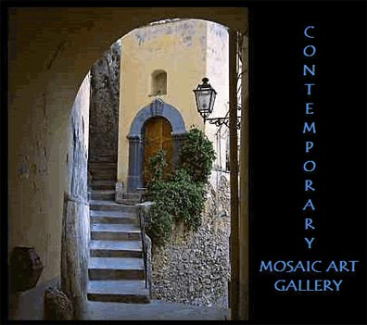
Contemporary Mosaic Art Galleryrepresents ten of the finest mosaic artists in the world, Giulio Menossi from Italy,Martin Cheek from the UK, Ginger Terry, Deborah Wahl, Jacqueline Iskander, Carol Shelkin, Jacki Gran, from the USA,Sophie Drouin from Canada, David McDonagh from Ireland, and Lubosz Karwat from Poland.
The style and presentation of the mosaics are all very different, from the very traditional to the modern, abstract and decorative.
Each piece of art is original and hand crafted by the artist using either traditional tools or modern implements.
The artists bring to their work countless hours of dedication to give life to their designs, in a way that best communicates their connection to the material and the message they are communicating. The result is a treasured piece of art that gives these mosaic works a mystical and transcendent quality.
What makes mosaic art so amazing? Each tesserae is cut by hand with great precision to create the exact shape for a specific position in the design. Standing close to the mosaic each tesserae is visible, standing further away the individual tesserae aren’t seen any longer and the mosaic is seen as a whole.
Mosaics have been contributing their richness to our lives for centuries, helping us understand the world around us through symbol, political statements, religious stories and cultural influences, by enriching our environments in public and private spaces. The current resurgence in contemporary mosaics offers all of these same enriching qualities to our lives in public and private spaces today as they have done in the past.
Contemporary Mosaic Art is definitely an option for investment, for collectors wanting to acquire a beautiful mosaics at the beginning of an artist's career, for home owners and decorators wanting a unique piece of art to captivate and excite the senses (and as unique conversation pieces) and for public galleries, wanting to provide for their members and visitors the newest and most innovative art.
Contact Details: Pam Givens
200 Coyote St
Nevada City, California 95959
530 575 6044
pamgivens@gmail.com
http://www.contemporarymosaicart.com

