Frontline And New Book Highlight Effect Of Parkinson’s On Families

Released on: February 24, 2009, 12:44 am
Author: Arbor Books
Industry: Healthcare
(Springfield, GA)—The recent Frontline special “My Father, My Brother, and Me” explored the effect that Parkinson’s disease (PD) has on the children of PD patients, a topic also explored in a recently published book by Parkinson’s in the Park founder Kay Mixson Jenkins.
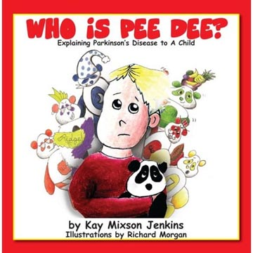
Ms. Jenkins was diagnosed with PD at the age of thirty-four and has been an advocate for research and patient support since. Her book, Who Is Pee Dee? Explaining Parkinson’s Disease to a Child, addresses the impact the disease has on the relatives of those with PD—especially their children.
Talking with a child about a disease that manifests itself through physical symptoms can be difficult because of the mental toll it also takes on a family. It’s a conversation that more and more people are having with their kids. More than six million people worldwide have been diagnosed with PD, and one in ten patients diagnosed are under the age of fifty.
In Who Is Pee Dee?, Ms. Jenkins uses a stuffed Panda bear named Pee Dee and a boy named Colt to answer many of the most common questions that kids have about the chronic illness:
• What is Parkinson’s disease?
• Why is Mommy or Daddy upset?
• What can I do to help?
• Why is Mommy moving slowly?
“As I’ve gotten older,” says Ms. Jenkins, “the disease has progressed. There will come a day when I’ll have to use a cane or a wheelchair, but I am determined to make my grandchildren proud of their ‘Muffin.’ I’m not going down without a fight.”
Ms. Jenkins says that it is crucial for people living with Parkinson’s to have resources to help them adjust to their new lives. Who is Pee Dee? includes pages of resources for adults, including websites, support groups and more.
Kay Mixson Jenkins is the Georgia state co-coordinator for the Parkinson’s Action Network, leads the Effingham County Parkinson’s support group and was selected as a Parkinson’s patient advocate for UCB, Inc.
For more information, contact the author directly via kmj@parkinsonsinthepark.org.
(Who Is Pee Dee? Explaining Parkinson’s Disease to a Child by Kay Mixson Jenkins; illustrated by Richard Morgan; ISBN: 978-0-9819129-0-5; $12.95; 33 pages; 8” x 8”; hardcover; UCB, Inc.)
Contact Details: Arbor Books, Inc. (ABI)
244 Madison Avenue, #254
New York, NY 10016-2819
PH: 212-956-0950
www.arborbooks.com

