Knockout Strategies Announces

Chris Mckay, National Radio Talk Show Host, Interviews Best Selling Author And Star Of A&E's Flip This House, Armando Montelongo


Released on: February 6, 2009, 10:31 am
Press Release Author: Knockout Strategies
Industry: Media
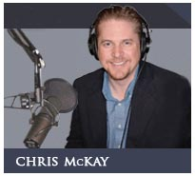
Following the success of his television show, Armando has taken time out of his schedule to write his 'rags to riches' story in his new book, Flip and Grow Rich. This heart-felt and personal book details his journey to financial freedom and the lessons Armando has learned on building his own successful business in real estate.
During his thirty minute interview with Armando, Chris candidly asks Armando why he feels compelled to share his own personal secrets to massive wealth. Armando explains that when he was at his lowest point in his life, thousands of dollars in debt because of medical bills and homeless, he made a promise to his wife that if he ever became successful, he would share it with other people.
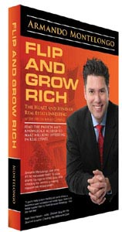
Chris continues to challenge Armando during the interview if now is really the best time to get involved in real estate. Armando emphatically believes that this is the best time to get involved in the real estate market because "America is on Sale" and the best time to buy anything is when it's cheap.
Through hard work, shrewd business acumen and a lot of determination, Armando has made his fortune in flipping houses and manages a major real estate firm today, Montelongo House Buyers.
The interview is engaging, personal and informative. This is a must have book for anyone who wants to take advantage of the real estate market and make huge profits in real estate investing.
Knockout Strategies has been retained as the radio production company and is the exclusive distributor of the Chris McKay show.
For more information contact:
Wendy Hague
207-591-6075 ext. 101
wendyh@knockoutstrategies.com

