Novotech Corporation Appoints Mr. Stefan Lindvall To Its Board Of Directors
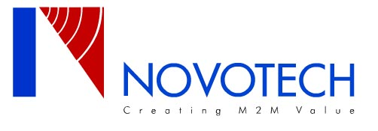
Released on: February 19, 2009, 12:05 am
Author: RICHARD HOBBS
Industry: Telecommunications
Ogdensburg NY, and Raleigh NC – February 1, 2009 Executive Team appointment further bolsters Novotech's strategic growth initiatives.
Novotech, a leading distributor of innovative and value-driven wireless communications products announces the appointment of Mr. Stefan Lindvall to its board of directors. Mr. Lindvall has extensive experience in the M2M marketspace having most recently served as President at Wavecom, INC responsible for the Americas.
"Novotech is pleased to have Mr. Lindvall join our board,” said Matt Dumais, President of Novotech. "Stefan brings a wealth of industry knowledge and experience to the company which will allow Novotech to further its' growth strategies globally.”
M2M solutions are available immediately through Novotech Technologies by calling 1-800-268-8628. With offices throughout the United States and Canada, Novotech is well positioned strategically and geographically to support the growing M2M needs of customers and manufacturers across varied industries.
About Novotech: Novotech is a leading distributor of M2M technologies in North America and has proven expertise in key technologies important to bringing M2M solutions and products to market. Over the past 14 years Novotech has been selling into the M2M marketplace and continues to be a reliable partner helping to integrate the right products to meet customer’s exact and demanding criteria -- whether they are currently engaged, or becoming engaged in the M2M space. Novotech has blended the leaders of M2M products in their respective technologies on one line card, thereby offering the most innovative and complete portfolio of market-leading products in the M2M marketspace today.
For more information please visit www.NOVOTECH.com
For further information please contact:
Richard Hobbs
Vice-President Sales,
Novotech Technologies Corporation Richard.Hobbs@Novotech.com
800 Proctor Ave
Ogdensburg NY 13669
Or,
Stefan Lindvall
Stefan.Lindvall@novotech.com

