Almost 1000 breast augmentation before/after photos online
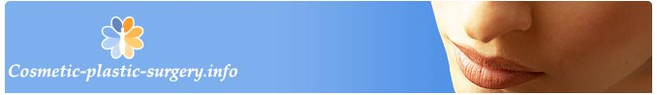
Released on: March 12, 2009, 6:03 am
Author: LekariOnline.CZ s.r.o.
Industry: Healthcare
Cosmetic-plastic-surgery.info, which provides information about cosmetic plastic surgery abroad, believes before/after photos are an important tool when making a decision on which surgeon to trust for your breast augmentation procedure. The website currently provides one of the largest breast augmentation before/after photo banks on the web. Almost 1000 before and after breast augmentation pictures from many doctors can be found at Cosmetic-plastic-surgery.info.
Pavel Hilbert, managing partner of Cosmetic-plastic-surgery.info, an information portal about cosmetic plastic surgery abroad, says some doctors prefer not to put photos of their work online in order to avoid promoting plastic surgery to youth. In some places, like Germany, it is illegal to show before/after photos until you have been contacted by a potential client.
“Most patients want to see photos and base their decision to contact a particular surgeon on their photo results,” says Hilbert. “Many doctors however think it’s more of a marketing tool and not exactly representative of a surgeon’s work as, of course, they’ll only publish their best samples.”
And what about the unrealistic expectations that so many cosmetic plastic surgeons have to contend with? The results of breast augmentation depend a lot on a body type; and wanting to replicate the look in a beautiful photo may not always be possible.
The purpose of the breast augmentation before/after photos at Cosmetic-plastic-surgery.info is to offer visitors another tool for their research. Use it, but don’t forget to take all potential surgery issues under consideration.
www.Cosmetic-plastic-surgery.info provides information about cosmetic plastic surgery abroad and presents it to the general public in Czech, English, German, Russian and more languages.
For more information contact:
Pavel Hilbert
Managing partner
E-mail: pavel.hilbert@cosmetic-plastic-surgery.info
GSM: +420.777.591.118
Fax: +420.222.587.203
www: www.cosmetic-plastic-surgery.info
Contact Details: LekariOnline.CZ s.r.o.
Dr. M. Horakove 513
Liberec
460 01
www.cosmetic-plastic-surgery.info
pavel.hilbert@cosmetic-plastic-surgery.info
GSM: +420.777.591.118
Fax: +420.222.587.203

