Kaenon Polarized Introduces the New Arlo™ Sunglass

Simple styling meets phenomenal fit and perfect polarization
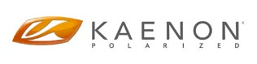
Released on: March 5, 2009, 7:21 am
Author: Kaenon Media/Kaenon Polarized
Industry: Retail
Newport Beach, CA — March 4, 2009 — Kaenon Polarized™, the Southern California-based Luxury Performance™ sunglass brand, proudly announces the arrival of its newest lifestyle-inspired sunglasses for spring 2009. ARLO™ – characterized by its conservative, good looking design and universal fit, accommodates a wide range of face shapes.
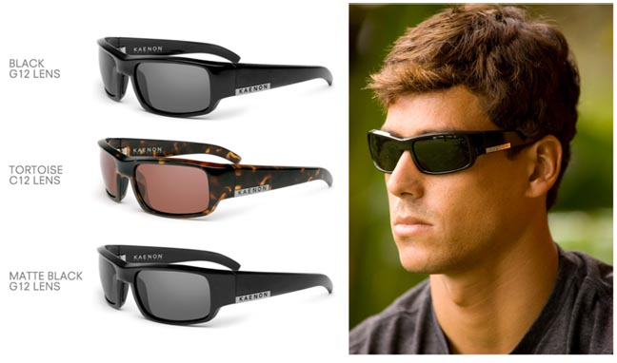
Blending sophisticated street appeal with Kaenon's SR-91® polarized lenses, these sunglasses offer superior optical clarity, color contrast, and depth perception in a lightweight, impact resistant package. ARLO is the latest addition to Kaenon's quiver of uncompromising selection of sunglasses.
With its elegant lines, scripted metal inlay on the temples and 5-barrel metal hinges, ARLO is perfectly suited for any uptown excursion or outdoor adventure. The unisex design of ARLO offers an exceptionally comfortable sunglass fit for a wide variety of men's and women's face sizes. The Italian crafted TR-90 injection-molded frame keeps ARLO strong yet flexible. Subtle no-slip Variflex™ nose pads anchor ARLO to your face, while adding all-day-every-day comfort.
As the newest addition to Kaenon Polarized's sunglass line, ARLO is available in Black with SR-91 lenses in Grey12, Matte Black with Grey12, and Tortoise with Copper12 lens options. As with all Kaenon Polarized sunglasses, ARLO is Rx adaptable and custom lens tints are available for nominal charge. Retail price: $199.
Founded by elite-level sailor, Olympic sailing coach, and Southern California native, Steve Rosenberg and his brother Darren, Kaenon Polarized represents the culmination of Rosenberg's 20+years of experience in the sports optics world as a sponsored athlete, sports marketer, and executive. Since its launch in 2001 with its patented SR-91 lens, Light Transmission Level Technology, and award winning KORE product, Kaenon Polarized has continued Rosenberg's mission to provide the elite athletes and active lifestyle enthusiasts with the clarity of polarized optics and high-performance frames with superior fit and luxurious style. Today, Kaenon Polarized is the Luxury Performance choice of professionals in both land and water sports such as golf, baseball, snow, surf, kitesurfing, windsurfing, fishing, sailing, and automotive racing, as well as entertainers in film and music.
Contact Details:
Kaenon Polarized  864 W. 16th Street  Newport Beach, CA 92663  (866) KAENON-1  www.kaenon.com | Media Contact:  Chris Denny  435.655.1609  chris@dennyink.com

