Medelita Expands Sales Force to Include Wholesale Distributors


Released on: April 13, 2009, 2:24 am
Author: Medelita
Industry: Apparel & Fashion
Innovative medical apparel company seeks independent sales reps serving the medical community
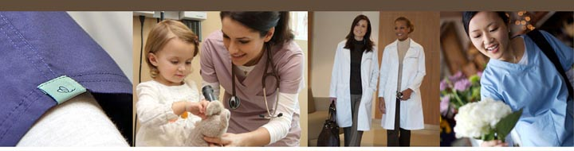
San Clemente, Calif., April 10, 2009 -- Medelita™, maker of breakthrough medical apparel for female clinicians, today announced the addition of its wholesale division. Based on successful web site sales and enthusiastic responses at medical conferences, Medelita has created a wholesale division to supply uniform retailers, medical offices, medical clinics, hospitals, and medical schools. With the support of leaders in the fashion and textile industries who share the vision, Medelita has, in a very short time, created a new standard for fashion, fit, and function within the medical uniform industry.
Sales to female physicians, physician assistants, nurse practitioners, and medical students, on the web site and at medical conferences, have shown that there is an even greater demand for Medelita’s lab coats and scrubs than originally estimated.
“Having the opportunity to build a new sales organization around a product line that is so demonstrably superior to what’s currently out there in the marketplace is an opportunity that rarely comes along in someone’s career,” said Joe Francisco, vice president of sales, Medelita. “Because the product line is so innovative, in so many ways, the cost of manufacturing and our price points are naturally higher. We’ve validated our products’ demand and confirmed that the price points were set correctly. We found the magic number. “
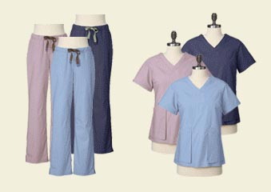
Francisco will head up the new division, bringing to his post, years of experience as a national sales executive managing sales staff and independent dealers and distributors.
At the foundation of Medelita’s sales force will be independent sales reps assigned to specific geographic territories. Although this model is early in its development, the program has piqued the interest of individual sales representatives, rep groups, and international group purchasing organizations that have experience selling to the medical community. Some will focus on retail uniform shops while others will focus on specific medical specialties, individual medical offices and institutional buyers. To date, 12 geographic territories have been assigned.
As the wholesale program expands, Medelita will introduce programs specifically designed to support the company’s reps as they enter the vertical markets within the medical community. The beauty of the program is its no frills method to overcoming any conceivable objection that a buyer could raise. Experience has shown that the best way to overcome objections is to simply ask them to try on a Medelita lab coat or scrubs. The product literally sells itself.
For more information about Medelita Wholesale, contact Joe Francisco at joe@medelita.com.
About Medelita
Medelita has one purpose: to reinvent the way women of all healthcare professions present themselves at work by offering the highest quality, best fitting, and most comfortable medical apparel available, including lab coats , women’s lab coats, women’s scrubs and medical scrubs. Medelita caters to professional women who want their uniforms to embody the poise and confidence already displayed from within. For more information, visit our website at http://www.medelita.com or call (877) 987-7979.
# # #
Contact Details: Joe Francisco
Medelita LLC
joe@medelita.com
(877) 987-7979

