SurgiCare reports huge rise in number of breast surgery enquiries
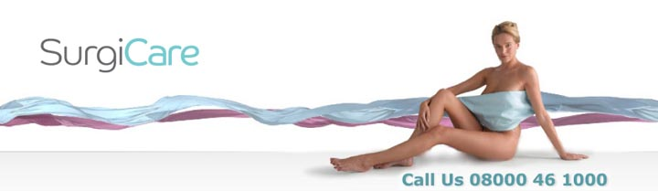

Released on: April 28, 2009, 4:57 am
Author: SurgiCare
Industry: Healthcare
SurgiCare has revealed a large rise in the number of enquiries from patients in relation to breast surgery procedures, as well as an increase in the number of breast surgery consultations that have been carried out.

New data from SurgiCare has revealed that enquiries regarding breast augmentation have risen from 485 in March 2008 to 624 in March of this year. Moreover, the number of breast surgery consultations carried out by SurgiCare has also increased by 28% over the
past year.
These new breast surgery figures from SurgiCare support the trends reported by the British Association of Aesthetic Plastic Surgeons, who found that breast augmentation procedures rose by 30% from 6487 in 2007 to 8439 last year.
SurgiCare carried out 105 breast augmentations through its clinics across the UK in January but has already performed 183 procedures so far in April.
One of the main reasons cited for the rise in breast enlargement and augmentation procedures is women wanting to look their best on their wedding day. 60% of patients questioned said they were undergoing the procedure specifically to look good for their forthcoming wedding during the summer. Mark Bury, Chief Executive at SurgiCare, commented that the company had to turn away frantic women who had not left enough time to fully recover from the operation ahead of their wedding, with it taking close to six weeks to fully recover from breast surgery and about three months to see the best results. Macrolane treatments have proved to be a popular option for women who have this dilemma, as it is an injectable filler that increase the size of the breasts, making them softer and fuller instantly, at a significantly lower cost that other cosmetic surgeries.
About SurgiCare
SurgiCare is one of the largest and most respected cosmetic surgery networks in the UK. SurgiCare was established more than 16 years ago by a leading professor of surgery, now its medical director, who also chairs its in-house Medical Advisory Committee.
As one of the leading UK specialists in cosmetic treatments, SurgiCare has the experience, latest therapies and the caring, professional staff to enhance a patients self-confidence by improving appearances. SurgiCare prides itself on providing an unrivalled aftercare service with all surgeons registered on the General Medical Council Specialist Register, to ensure every patient receives the best possible standard in care and results.
SurgiCare has helped more than 20,000 patients fulfil their dreams of looking and feeling their best. SurgiCare also specialise in Weight Loss Surgery with a unique 24 month support programme and lifetime aftercare.
For further information contact:
SurgiCare Limited
Parkway House
Palatine Road
Northenden
Manchester
M22 4DB
0800 046 1000
www.surgicare.co.uk

