Lexington Medical Center Is First Hospital In South Carolina With Incisionless Surgery
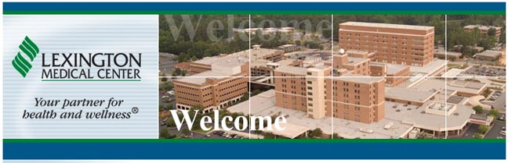

Released on: June 12, 2009, 6:13 am
Author: Jennifer Wilson/Lexington Medical Center Public Relations Manager
Industry: Healthcare
Lexington Medical Center has made medical history by becoming the first hospital in South Carolina with incisionless surgery.
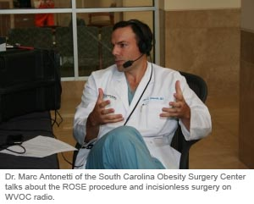
The South Carolina Obesity Surgery Center, a physician practice affiliated with Lexington Medical Center, is now offering “the ROSE procedure” and performed it for the first time at Lexington Medical Center this week. ROSE stands for Restorative Obesity Surgery, Endoscopic. This procedure is for patients who have gained weight back after gastric bypass surgery. Currently, only approximately 30 facilities in the United States offer this treatment.
During ROSE, the surgeon will insert an endoscope through the patient’s mouth into the stomach pouch. The doctor then creates folds to make the stomach pouch smaller. Because there are no external cuts into the body, the procedure offers the advantages of reduced risk of infection, less post-operative pain, faster recovery time and no scars. The treatment can be especially important in South Carolina, which ranks 5th in the nation for obesity.
Dr. Marc Antonetti and Dr. Glen Strickland of the South Carolina Obesity Surgery Center completed special training to do the ROSE procedure at the Baylor College of Medicine in Houston, Texas earlier this year. Each procedure takes about 1 ½ hours. Patients may be in the hospital less than one day. The ideal candidate is someone who had gastric bypass two years ago, lost greater than 50% of their excess weight and regained greater than 10%.
Before the ROSE procedure, patients who regained weight after gastric bypass surgery had few treatment options. Scarring from the initial procedure made revision surgery challenging, with longer recovery time and an increased risk for complications.
Some patients regain weight after gastric bypass surgery because of gradual enlargement of the surgically altered small stomach pouch. In weight loss surgery, the stomach pouch is made very small, which creates a feeling of fullness after just a small volume of food is eaten. When the pouch gradually enlarges, the feeling of fullness is no longer present, patients can eat larger meals and weight regain occurs.
Doctors say similar incisionless surgery may have future application for gall bladder surgery and appendectomies.
The South Carolina Obesity Surgery Center is dual-certified as a Center of Excellence in bariatric surgery by the American College of Surgeons and the American Society for Bariatric Surgery. Its doctors are Dr. Antonetti, Dr. Strickland and Dr. Jim Givens. The surgeons there have completed more than 3,000 bariatric surgeries.
News reporters who wish to do a story on the procedure, its patients and doctors should call Jennifer Wilson at Lexington Medical Center at 803-791-2191. For more information on the South Carolina Obesity Surgery Center and the ROSE procedure, go to www.scobesity.com.
About Lexington Medical Center
Lexington Medical Center, in West Columbia, S.C., anchors a county-wide health care network that includes six community medical centers throughout Lexington County and employs a staff of 5,100 health care professionals. The network also includes the largest extended care facility in the state, an occupational health center and physician practices. At its heart is the 384-bed state-of-the-art Lexington Medical Center, with a reputation for the highest quality care. Lexington Medical Center was voted one of the “Best Places to Work” by the South Carolina Chamber of Commerce, “Best Hospital” by readers of The State for nine years in a row, “Best Hospital” by readers of the Free Times and “Best Place to Have a Baby” by readers of Palmetto Parent. Visit www.lexmed.com or www.lexmed.tv.
Contact Details: Jennifer Wilson
Lexington Medical Center Public Relations Manager
2720 Sunset Boulevard
West Columbia, SC 29169
jawilson2@lexhealth.org
803-791-2191 or 803-939-4512

