Premier Online Check Company Carousel Checks Issues Vietnam Wall Commemorative Checks


Released on: June 26, 2009, 3:10 am
Author: Marley Masters
Industry: Financial
Crestwood, IL – June 18, 2009; Nearly 35 years after the final American helicopter flew out of Vietnam, the memory of more than 50,000 American men and women who lost their lives in the conflict is preserved forever in the black marble walls of the Vietnam Veterans Memorial. Since it was first unveiled in 1982, it has become as recognizable as any other monument in Washington, D.C. and a place of healing for countless veterans of the war and their families.
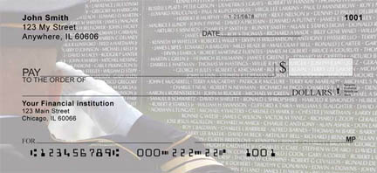
Carousel Checks, an online provider of personal, business, computer, laser and bank checks worldwide, recently announced the release of “The Wall,” a stirring photograph adorning the company’s newest addition to its American Pride line of commemorative checks.
The design on the checks respectfully depicts a portion of the Vietnam Veterans Memorial with a proud U.S. Marine saluting in the foreground. Names of many of the fallen can be clearly read in the design.
“The wall is such a stark reminder of the selflessness that our fighting men and women exemplify,” Andy Crim, president of Carousel Checks, said. “We received many requests from veterans and their families for a Vietnam-themed design. We chose this one because it is both heartening and solemn.”
The Vietnam Wall design joins a growing number of Americana-based check designs for the 40-year-old Carousel Checks Company. Other patriotic photos available in the American Pride line of custom checks include Mt. Rushmore, The Lincoln Memorial, the Statue of Liberty, the POW-MIA logo and several attractive “Old Glory” patterns.
“American history and Americana in general is very popular on personal checks,” Crim said. “These checks have always among our most popular designs. “ Crim added that he had no doubt that the Vietnam Wall check design would become quite popular.
“Obviously, veterans of the Vietnam War identify with it,” Crim said. “But so do the families and survivors of the men and women whose names are on the wall.” Crim added that Carousel Checks has already received many “thank you’s” from people who have ordered the online checks at the company’s site, carouselchecks.com.
“They’re truly moved by the design,” Crim said. “People tell me that the checks instill a feeling of pride every time they open their check books.”
Carousel Checks was founded over 40 years ago by Crim’s parents as a regular check printing company for banks around the country. When the internet made custom printing of checks a reality for many consumers, Carousel was one of the first companies to pursue the consumer end of the checks business.
Currently, CarouselChecks offers scores of check designs in a variety of categories, from Americana and sports to religion, education, sports, wildlife and seasonal designs.
Crim said that the Wall check design is available in a variety of package sizes. Retail prices range for $10 to $80, based on the quantity of checks ordered. The entire CarouselChecks product line is available online at Carouselchecks.com.
Contact Details:
Andy Crim
888-422-6122
Carousel Checks Inc.
4333 136th Court
Crestwood, IL 60455

