Al Unser Jr. and Motor Media to Hold Race Clinic

Released on: April 08, 2010, 9:26 pm
Author: Htor Media USA§
Industry: Hports§
Racing clinic held by two-time Indy 500 winner and two-time Indy Car Series Champion Al Unser Jr will benefit the Johns Hopkins Hospital's Miami Project
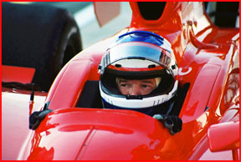
Millville, NJ (April 8, 2010) – Al Unser Jr will launch his first racing clinic to benefit The Johns Hopkins Hospital's “Miami Project”. On July 8th, 2010, winners of a low-unique-bid-wins auction will bring a guest to enjoy racing lesson from Al Unser Jr and dinner with the champion himself.
Auction winners will drive open-wheel race cars and learn driving tips American Racing Champion Al Jr at world-class racing facility New Jersey Motorsports Park. Winners will experience champion speeds in a supercar in a private "hot laps" session with Al Jr. Drivers Al Unser III and Miranda Throckmorton will also be on-track to assist Al Jr's instruction.
The Al Unser Jr Charity Auction proceeds will benefit the Johns Hopkins Hospital's Miami Project, devoted curing paralysis. "I am very excited to hold my first driving clinic to share what I have learned in my career about driving, and at the same time raise money to help find a cure for paralyses," said Al Jr. The auction is now online at ww.alunserjrcharityauction.com§, and is open to bidders world wide.
For more information:
Motor Media
Indian Smith
732-203-7787
ndian@motormediausa.com§
###
~~~~~

Press release distributed via EPR Network ( https://express-press-release.net/submit-press-release.php)

