Nairobi City Tours and Kenya Safari Packages
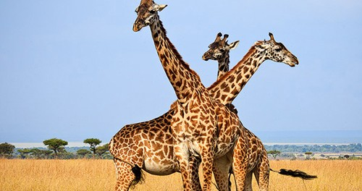
Twiga Safari

Nairobi, Kenya, April 19, 2016 — /EPR NETWORK/ — Cruzeiro Safaris Provides Services For Nairobi Day Tours, Nairobi National Park Tour, Nairobi City Tour, Masai Mara Safari Packages, Kenya Accommodation, Safari Twiga, Kenya Safari Packages And More. Games drives in Nairobi national park are done with safari minivans however, those who fly to the Masai Mara, Samburu, Meru, Kalama, Aberdares will do game drives in 4×4 wheel drives. One can request a 4×4 wheel drive for safaris of more than 2 days Upon request.
With the ever increasing demand for suitable travel and safe destinations Kenya, Tanzania and Seychelles remain on top of the list. With suitable tailored Packages such as:
Summer Package for 6 days from Mombasa airport and back to Mombasa. This is a 4-star accommodation facility situated in Kikambala (along Mombasa-Malindi road) about 25 kms from Mombasa town. The hotel faces Indian Ocean and rests on white sandy beaches. The structure and spectacular interior décor inspire a heavenly mood, a superlative getaway where work-related stress simply melts away. We combined a 4 night stay with a 2 night stay at the Tsavo East and West National Park. Prices start from Euros 981/ USD1099 per person sharing.
According to the popular magazine tour-expi mobile travel bookings in 2016 have greatly increased as popular bookings from Get Your Guide for people travelling to Nairobi, Kenya. Through its online payment system which is simple and direct Cruzeiro Safaris limited in Nairobi offers many offers to book online such as https://www.cruzeiro-safaris.com/4-days-lake-nakuru-maasai-mara, https://www.cruzeiro-safaris.com/safaritwiga,https://www.cruzeiro-safaris.com/3-days-amboseli-park, With scheduled monthly dates for 6 days https://www.cruzeiro-safaris.com/safarindovu, Amboseli Park for 2 days, to theAberdares National Park and Solio Ranch in the Mount Kenya Region, to the 3 days Masai Mara Safari National reserve, or the flying package for 3 days special offer from April- June, 2016. Tours from Nairobi can also be booked ahead on viator a major tours selling site by following this link https://www.partner.viator.com/en/18674/travel-tips/Nairobi-City-Tours-/ttd Delegates coming to Conferences In Nairobi in 2016 can book Nairobi Airport Transfers through the above site or check out on paypal.
Flying packages are a fast way to get to places within Kenya and get to enjoy the wildlife we have the following package on offer such as Kichwa Tembo Tented Camp, Keekorok Lodge, Governors Camp Masai Mara, Mara Intrepids Club, Masai Mara and Mombasa and Single Travel Package to Amboseli, Samburu and Masai Mara in Luxury accommodationhttps://www.cruzeiro-safaris.com/single-travel-package and finally to the further north to Lake Turkana for 3 Days.
Are you attending any of these conferences in Nairobi namely UNCTAD 14 2016, ICT4D2016 IN KENYA, UN Environment Assembly UNEA, Jesuit Forum in Nairobi, TICAD 2016 in KENYA and many others? There are many interesting tours and safaris that one can take from Nairobi and Mombasa.
One can also use Contact US form, or Ask a Question? to make any enquiries.
ABOUT US:
Cruzeiro Safaris Limited is a tours and travel company based in Nairobi, Kenya. It’s mandated to provide tours and safaris to everyone willing to be enlightened about travel destinations priority being Kenya then other countries. It also provides Affordable Air tickets worldwide. One can read trip advisor nairobi reviews or read all traveler reviews.
Contact-Details: Cruzeiro Safaris Kenya | URL: www.cruzeiro-safaris.com | Email| info@cruzeiro-safaris.com Tel: +254-722-370833 or +254-710-729021
Mumias South Road, Buru Buru Shopping Center, Visions Place
###
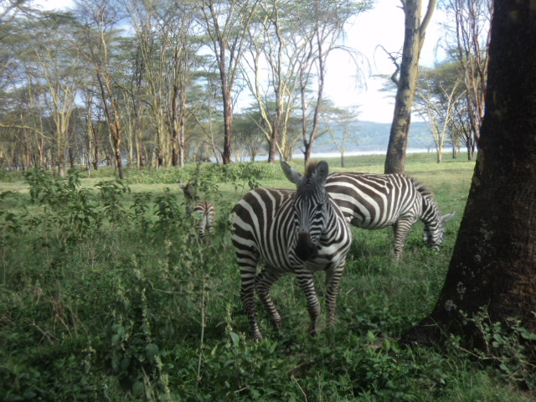
Masai Mara Safari
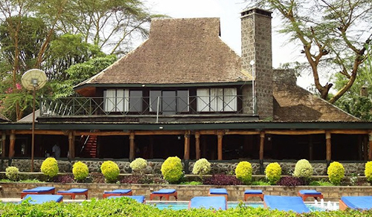
Lake Nakuru National Park
~~~~~

Press release distributed via EPR Network (http://express-press-release.net/submit-press-release.php)

