DESIGNER GIONNI STRACCIA LAUNCHES HIS FIRST FASHION COLLECTION

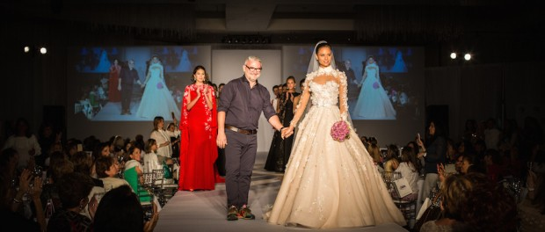Gionni Straccia Fashion Show
• SPRING 2017 COLLECTION inspired on flowers, romance and femininity
• A runway in support of WIZO Florida was the scenario for the catwalk
Miami, FL, 2016-May-16 — /EPR Network/ — Venezuelan designer Gionni Straccia (www.gstraccia.com), a well-recognized figure in the couture fashion world, debuted yesterday his first collection ever; the “Gionni Straccia Spring 2017 Collection”. The fashion show took place during the “Mother’s Day Sponsor-a-Child Luncheon and Bazaar”; a non-profit event organized by the ladies from the Women International Zionist Organization (WIZO Florida), in the ballroom of the Beth Torah, Benny Rok Campus, located in the city of Miami.
With an inspiration that blended romance and femininity, Gionni Straccia Spring 2017 set the stage for exclusive designs that revealed the richness of a flower – expressing the sweetness and tenderness that flow from it- but highlighting a touch of excitement for the subtle, elegant and tasteful woman.
More than 300 guests were entertained while fabulous models, that included one Miss Universe, showcased the new clothing collection dominated by the use of two Straccia’s favorites: crepes silk and laces. Also, Italian tulle and organza embellished exquisite dresses, most of them with artistic embroidered and hand-painted flowers. Keeping with the trending cape dress, the designer offered a complete collection of stunning short cocktail dresses, pants suits, and evening gowns, that came in white, black, red, pink, and navy colors. Responding to a woman’s dressing needs for the different occasions in her life, Straccia added to the collection an astonishing wedding dress that left attending crowd impressed by the beauty and elegance of this piece.
Known for elegance and made-to-measure inimitable styles among the most important beauty pageants, Straccia is starting a new stage in his successful career; most importantly, with the recent opening of his private atelier in the United States. The Italian-Venezuelan designer is excited with the accomplishment of his very first full collection, “I am really very happy with the outcome. I wanted to express women’s romanticism, femininity and their sweetness,” said Straccia, “and I tried to rescue a technique of hand-painted flowers, to be in tune with the latest fashion trends, but highlighting the indelible Gionni Straccia stamp”.
The WIZO Florida, “Sponsor-a-Child” event included a bazaar with an exclusive diverse group of exhibitors that showcased beautiful pieces in jewelry, decorative items, clothing and many other accessories. As part of its annual gathering, WIZO Florida honored one of its members with a ‘Mother of the Year’ award. This time the privilege went to Colombian native, Margie Szerer, for exemplifying a WIZO woman, dedicated to her family, committed to Israel and a true leader for WIZO Florida.
“We are very proud to have presented renowned designer Gionni Straccia’s spring 2017 Collection at our ‘Mother’s Day Sponsor a Child’ fundraising event” said Suzanne Berkovits Harper, Director of WIZO Florida. “This event has grown each year and has become an icon in our community and one of the premier Mother’s Day events in South Florida, honoring and remembering mothers while benefiting women and children in need in Israel.”
Recognized fashion executive, Beth Sobol, produced the event.
Contact-Details: Amarilis Zozaya/AZ Communications, Inc.
amazozaya@gmail.com
305-495-3215
~~~~~
Press release distributed via EPR Network (http://express-press-release.net/submit-press-release.php)

