Introducing Torque Control Cordless Angle Wrenches from Express Assembly Products
Nashua, NH, 2016-Jul-14 — /EPR Network/ — Express Assembly Products has extended it cordless Li-ion battery torque line with two new Angle Torque Wrenches. Our new Angle Torque Wrenches have brushless motors for more power, high precision full auto shut-off clutches for torque accuracy and improved battery life, adjustable angle heads for ease of use, external torque adjustment for torque control, and built-in smart logic for battery conservation. Jack Hagerty, head of sales, for Express Assembly Products says “We have experienced a huge demand in the assembly industry for repeatable reliable torque with the freedom of cordless tools. These new cordless torque wrenches meet that demand and we now have many customers using these tools in their assembly applications.”
EAW Cordless Angle Wrenches specifications:
Model: EAW-B1830-20 drive = 3/8”, torque = 8.85 – 22.12 ft-lbs, RPM 270/420
Model: EAW-B1860-40 drive = 1/2”, torque = 18.44 – 44.35 ft-lbs, RPM 130/200
Our cordless torque tools come with brushless motors, a 2-year warrantee and a certificate of torque accuracy. Its ergonomic design reduces the counterforces felt by the operator reducing overall operator fatigue. Sumake tools are manufactured for today’s complexed industrial assembly applications.
Express Assembly Express Assembly Products is one of the largest single sources of light torque assembly tools and related products on the web. The company offers a wide range of electric, pneumatic and torque screwdrivers, as well as a full range of accessories and stands for industrial assembly. Express Assembly offers a Calibration Certification program and is an authorized service center for all screwdrivers and torque meters that it sells. For more information, please visit www.expressassembly.com
Contact:
Express Assembly Products, LLC
One Chestnut Street
Suite 215
Nashua, NH 03060
1-866-863-2302
info@ExpressAssembly.com
www.ExpressAssembly.com
Deanna Zell
Express Assembly Products
603 578-9965
info@ExpressAssembly.com
www.ExpressAssembly.com
###
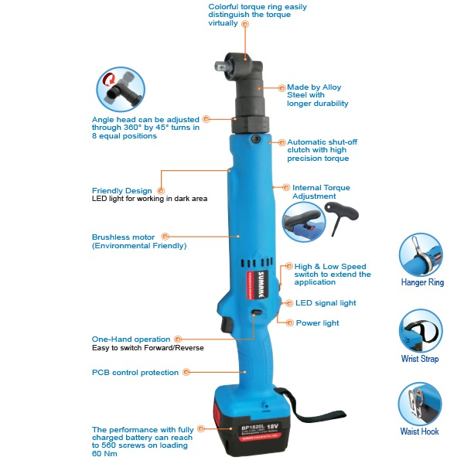
Press release distributed via EPR Network (http://express-press-release.net/submit-press-release.php)

