Environmentalist Lori Grace of Tiburon funds Biorock Technology project to contribute to help SF Bay underwater life

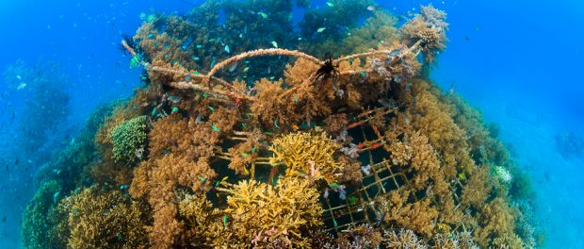
Bio-Rock Pemuteran Bali Indonesia / Photo by EunJae Im | www.eiLabs.net
Tiburon, CA, 2016-Sep-03 — /EPR Network/ — Lori Grace, founder of the Bay area organization, Save Our Bay, Save Our Ocean, a division of Sunrise Center, is now funding Tom Goreau of the Global Coral Reef Alliance to work with the Romberg Environmental Research Center in Tiburon in a Biorock project that, if successful, will assist the SF Bay Area in supporting salt marsh, oyster and eel grass growth . It will also help reduce sea level rise at the same time.
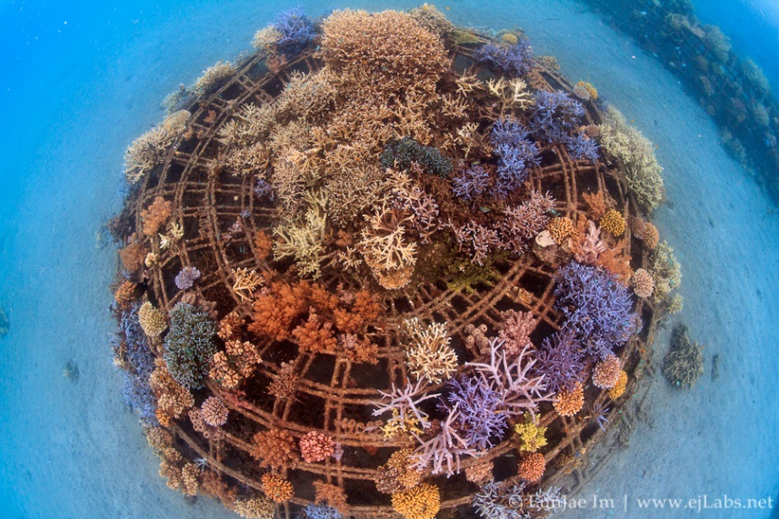
Bio-Rock Pemuteran Bali Indonesia / Photo by EunJae Im | www.eiLabs.net
There is great excitement at the County, NERR, and Richardson Bay Audubon about the possibilities offered by bringing this technology to the SF Bay Area. The results will definitely be fully assessed in the experimental tanks of the Romberg Center by June 2017.
After showing the success of Tom Goreau’s Biorock technology in a tank, plans are to introduce this technology with the County’s approval to the Richardson Bay Audubon sanctuary, Bothin Marsh, the Corte Madera Salt Marsh, and Stinson Beach among other locations.
Media contacts: Edward Ellsworth, 6 Playa Verde, Tiburon, CA 94920
http://saveourbaysaveourocean.org/
https://www.youtube.com/c/sunrisecenterchannel
http://www.globalcoral.org/
Press release distributed via EPR Network (http://express-press-release.net/submit-press-release.php)

