Trappist Westvleteren online

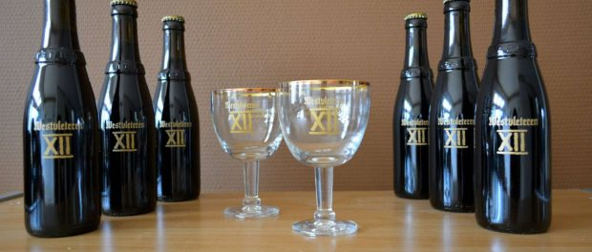Trappist Westvleteren online
Westvleteren, Belgium, 2016-Sep-11 — /EPR Network/ — Trappist Westvleteren 12, brewed by the Saint Sixtus monks in Belgium, has been rated as the best beer in the world in 2014 and 2015 by Ratebeer and Beeradvocate. Until recently, the beer was only for sale at the Abbey or in the nearby café “In de Vrede.” Recently, Westvleteren has launched a website where customers can buy Westvleteren online. The beer will be delivered worldwide by courier. This is an opportunity to get some six packs, cases, glasses or gift packs from the different Westvleteren beers.
Founded in 1883 by Belgian Trappist monks, Westvleteren 12 is considered to be the world’s best beer. Awarded twice, this Trappist beer with creamy aromas has been the holy grail among beer lovers all around the world.
Trappist Westvleteren 12
Of all Trappist beer breweries, the Saint Sixtus Abbey of Westvleteren applies in the strictest rules. The Trappist monks only produce enough beer to continue their life as monks and not to make money out of this business. This is their tradition since the first bottle of Westvleteren was made.
Westvleteren 12 is very hard to find. The Trappist monks produce their beer in very limited numbers (about 2 crates a day). Westvleteren 12 and Westvleteren 8 are extremely rare beers, wanted by about every beer enthusiast in the world. Now people from around the world are able to buy Westvleteren 12 and try it, previously the beer was only to be sold from their brewery. Until now!
Westvleteren 12 for sale
Now that the monastery requires new structural maintenance, doors, windows, roof and etc. they have allowed sales in Switzerland, France, Spain, Italy, the Netherlands and the United States.
So today, all people can order online from now on, visit us at http://www.westvleterenbeers.com and keep in mind that the number of beers is still limited, but customers can enjoy the convenience of not going to Belgium and order the beer from home. The Trappist monks make two other kinds of beer: Westvleteren blond beer and Westvleteren 8. Both are excellent and can be also bought online.
Contact-Details: Westvleterenbeers, info@westvleterenbeers.com, http://www.westvleterenbeers.com/

