Ellen London to unveil new collection of wearable art at International Couture Runway at DC Fashion Week on September 24
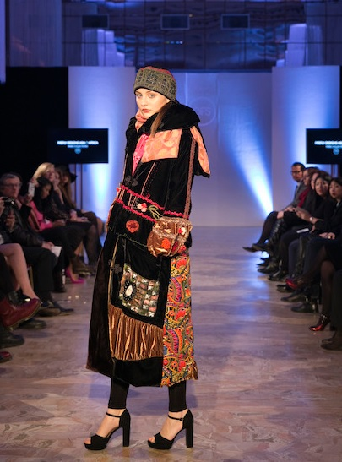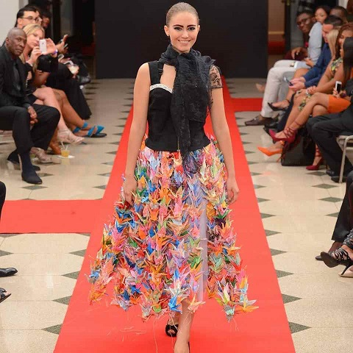
Bangkok, Thailand, 2016-Sep-22 — /EPR Network/ — With the introduction of her printemps/été 2017 collection, ellen london introduces admirers of her designs to our diversity and similarities of different countries and cultures through beautiful and creative wearable art. She deliberately focuses on the “mobile” art of fashion as the method to teach understanding and respect for cultures – especially ones that are stereotyped and vulnerable.
Her clothing combines fabrics from different countries consistently maintaining the integrity of the authentic textile. Using backgrounds of silk, linen, cotton, cashmere – hand painting, embroideries and other elements may enhance the design.
The collection previewing at the finale International Couture Runway at DC Fashion Week runway on September 24 highlights textiles from the Middle East, North Africa, and Asia that have been redesigned into wearable works of art.
It has always been said about Ellen London’s work, “Do not wear if you do not want to be noticed.” Now the “notice” goes behind the beauty of the wearer, but extends to others as they learn to appreciate and respect other cultures and the beauty they create.
~~~~~
Press release distributed via EPR Network (http://express-press-release.net/submit-press-release.php)

