Baton Rouge Based Roof Crafters Launches New CRM Software For Clients

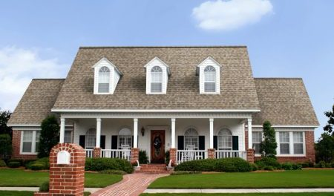

CRM Product Launch from Roof Crafters
Baton Rouge, Louisiana, 2016-Oct-12 — /EPR Network/ — Chuck Magee, construction professional and owner of Louisiana-based roofing company Roof Crafters, is proud to offer Louisiana clients more access and insight into the progress of their roofing projects.
As the most technically advanced roofing contractor anywhere, Chuck Magee and Roof Crafters have taken full advantage of cloud technology and developed their own proprietary cloud-based software system. This intuitive, easy-to-use system is only available in Louisiana to Roof Crafters clients.
Utilizing SSA Store Share Access, Roof Crafter clients will be able to track and keep up with all aspects of their roofing and roof related jobs, including warranty information, shingle type, shingle color and when the roof was installed. Pictures at various stages of the project are also provided.
Keeping this information properly stored and easily accessible is also vitally important for many clients that are having roof repairs performed due to damage from weather or other accidents. The portal makes it easy for clients to retrieve information for insurance purposes, or even if they wish to sell their house a number of years later and want to provide the buyers with the correct information about the roofing materials.
Working in construction for over two decades, Chuck Magee realized that a client-access system such as the one developed by Roof Crafters was sorely needed in the industry. Being able to access information at their leisure helps clients feel better about their projects and provides them with a more comprehensive, detailed record.
As a trusted expert in the industry, it was especially important to Chuck that his clients could get as much assistance and information as they needed when they needed it. He states that he is “especially excited to launch this new software for Roof Crafters clients to stay up to date on their roofing projects.”
Chuck knows that every roofing job is different, and having completed a re-roofing of his own home, he has firsthand experience of the challenges and inconveniences these projects can cause for his clients. This makes him a much more understanding and sympathetic consultant for those in the middle of a difficult roofing project, and it is why he thinks that the CRM product developed by Roof Crafters will be such a benefit to the residents of Louisiana.
Press contact:
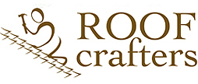
Roof Crafters LLC,
Chuck Magee,
4520 Sherwood Forrest Blvd Baton Rouge, LA
70816 225-667-1189, 888-846-1558,
https://theroofcrafters.com

Press release distributed via EPR Network (http://express-press-release.net/submit-press-release.php)

