EiVi – innovative period panties launched on Kickstarter

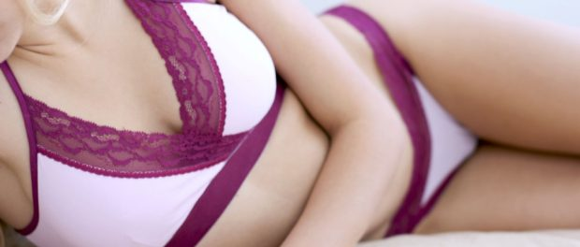
Chicago, IL, 2016-Oct-14 — /EPR Network/ — Women hygiene manufacturer “Genial Day” presented new invention EiVi – patent pending organic cotton panties with double crotch with pockets on the sides to hide pad wings.
Finally pads and panties were united for maximum comfort, health and fashion. It became a reality because of a small family business which worked in this field for many years.
„It has been a decade since our family started sanitary napkins business. Always our goal was the combination of health and comfort. That is why we use only the most advance materials in our pads: ventilated film, biodegradable superabsorbent polymer, air laid paper or ion strip. We are seriously concentrated to fight with pesticides, fungicides, toxic paints, chemicals equilibrate the pH, cellulose and chloro. We also are OEKO-TEX® 100 certified.” – says founder Vilmante Markeviciene.
Functionality and comfort depends on small details. The biggest secret of EiVi panties is a double crotch with pockets on the sides to hide Genial Day pad wings.
“We knew that we have amazing bullets to fight with toxins in women’s body. But the gun was missing. That is how EiVi was born – a line of organic cotton underwear collection designed to ease women’s periods. On top of that, cotton is finished with silver anions to protect body from bacteria, bad odor and allergies. So, health comes first.” – Vilmante says.
Woman can wear EiVi anywhere she wants even during her heaviest days; she doesn’t have to worry about anyone noticing her pad. Since underwear contains 8% elastane, it fits body perfectly in any situation. In addition, it always keeps its shape and style even after numerous laundry cycles.
EiVi comes live on Kickstarter with different styles and colors.
More information:
Kickstarter project: http://kck.st/2e9Ntej
Vilmante Manrkeviciene
Email: eivi@genialday.com
Press release distributed via EPR Network (http://express-press-release.net/submit-press-release.php)

