Startup mentored by Promwad created one of the best IoT products in Europe

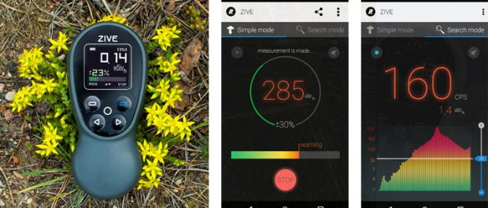

Vilnius/Lithuania, 2016-Oct-18 — /EPR Network/ — ZIVE smart radiation monitor has reached the final of Elektra Awards 2016, a big influential contest for the electronics market players. This device designed by R-NOX startup with the assistance of Promwad Electronics Design House was named one of six best innovative products of Europe exploiting the Internet of Things potentialities.
ZIVE is a portable radiation monitor of the next generation that can connect to smartphones and tablets via Bluetooth. It’s the first device of professional level designed for common people. It has a user-friendly interface, a Geiger-Muller counter, and a low market price comparing with other high-precision radiation monitors.
ZIVE radiation monitor measures gamma rays, ionizing radiation, and X-rays. Differentiating features of the device:
- Calibrated by accredited European laboratories (CE).
- High accuracy at a lower price in comparison with other similar devices.
- “Smart monitor” mode that provides users with specific health and well-being advice: how to interpret the measurements and reduce the risks.
- Working with maps to create eco-routes: save radiation spots, find cleaner routes.
The collected ZIVE data is used for the real-time global map of radiation contamination.
Roman Pakholkov, Promwad’s CEO and R-NOX’s mentor, says that the data collected by ZIVE users is stored in the eco-platform, which is becoming the most detailed in the world. This platform allows accelerating the innovations development for the environmental management and can be integrated into other devices and applications via the open API.
To date, R-NOX has developed partnerships with the largest tour operator in the Chernobyl Nuclear Power Plant Zone of Alienation; Greenpeace; companies and organizations in Japan, Finland, Singapore, and other countries.
Promwad continues its work in supporting new electronics design projects in the IoT field. The company believes in the high potential of this popular trend and are ready to share their experience in the development and manufacture of electronic products for the global consumer electronics market.
The best companies of Elektra Awards 2016 will be announced on Thursday, 1st December, at the awards ceremony taking place in The Ballroom, Grosvenor House Hotel, London.
Contact-Details:
Promwad
Olga Potonya
olga.potonya@promwad.com
+370 (5) 214 12 44 ex.227
Press release distributed via EPR Network (http://express-press-release.net/submit-press-release.php)

