AOSO Newly Released M16 Wireless Bluetooth 4.1 Headphones with Adjustable Neckband Oct.2016

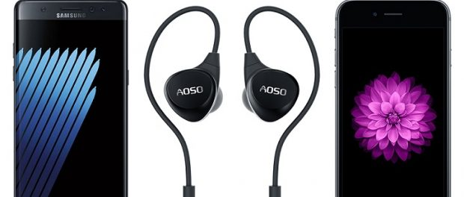
BUFFALO, NY, 2016-Oct-27 — /EPR Network/ — AOSO Newly released M16 Bluetooth Headphones take advantages of Bluetooth 4.1 version, providing universal compatibility with all Bluetooth-enabled devices, and automatically pairing your last connected device. LED indicator light can also show the remaining battery at your iphone / ipad. Users can pair 2 bluetooth-enabled devices simultaneously. This makes sure you won’t miss every incoming telegram when listen the music; you may listen to a few tracks of the same musical tracks – a classical musical track, a pop track, a rock track and an orchestral movie soundtrack track. The headphone performed steady and smooth over the various styles of music and it proved to be a decent all rounder. There was enough bass and the mid to high tones were clear too.
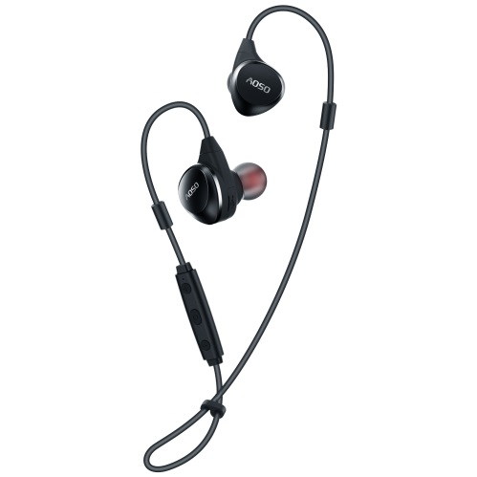
The headphone come in a a small round hard shell case that zips all the way around.and it is easy to pop them into a bag and the user doesn’t have to worry about the cord getting all twisted up or the ear cushions falling off. The inside of the bag has a mesh pouch on one side of the case that the charging cable can fit into. The Bluetooth earphones have a novel design which uses a bendable wire between the cable and earpiece which can be bent to the shape needed to be comfortable and secure for each individual’s ear.there is a small piece that slides up and down so that you can tighten them under your chin or behind your head. There are 3 sets of ear buds – small, medium and large equipped, the ear-bud portion is nice and fits the ear canal well respectively.
These earphones has an inline control panel with three buttons and a built in microphone. and there is a nice large control button on the front with raised buttons that are easy to reach to be able to control music and answer incoming calls. The sound quality of the headphones really is terrific. Which is build-in high-definition stereo sound, equipped with CVC 6.0 noise cancellation technology, leading to rich detailed sound by wireless stream with APTX for CD-like quality.the music is well balanced with good strong bass. It provides pretty loud when you enjoy your favorite music, the volume is pretty high and sound is much pure as original.
This bluetooth headphone is new released but with affordable price, this press has shown that it can deliver a powerful performance, and it doesn’t look too shabby, either. With such great value for money, this headphone comes highly recommended and can be found at http://www.aosotech.com/product_m16.php.
About AOSO:
AOSO offers reliable audio products like bluetooth speakers, gaming headsets, bluetooth headphones; and we aim to become the most trusted audio brand. AOSO are committed to becoming the most loved and trusted market place on the Amazon by offering a superior shopping experiences, rapid delivery and superior customer service.

Contact-Details: Bruce
79 Chatham Ave
Buffalo , NY 14216
United States
1-716-261-0446
E-mail: bruce@aosotech.com
Site: http://www.aosotech.com
Press release distributed via EPR Network (http://express-press-release.net/submit-press-release.php)

