Headline: CaboCribs.com Opens for Los Cabos Real Estate Enthusiasts
LOS CABOS, September 12, 2016 /PRNewswire/ --CaboCribs.com has officially announced its opening in Q3 2016 in the fastest growing retirement vacation destination in America, Los Cabos, Mexico.
"CaboCribs.com wants to provide every proven marketing and sales options to its clients. It is constantly striving for excellence in professionally handling all home buyers and sellers in buying and selling properties.From the genuine desire to offer homeowners and developers a broad-spectrum of guidance all throughout the steps of real estate marketing and sales processes, the team is now able tobecome the best guide in making dreams painlessly come true while making sure that every clientenjoys a relaxing and stress-free experience,"stated Leeroy Jarvis, Owner of CaboCribs.com.
In the creation process, the team’s desire to provide clients with user-friendly search options and guaranteed quality listings served as the main driving forceto make the magnificent tool come to life. The team wanted it to become the easiest platform for buyers to use when searching for quality properties. Its sole purpose is to BE THE TOOL that will let clients find and own a dream property effortlessly. Now, here it is!
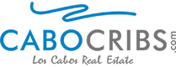
The platform offers a host of top-notch Los Cabos real estate located in amazing locations of Los Cabos: Cabo San Lucas and San Jose del Cabo. Moreover, it offers exciting designs, features, and services since the best web developers from North America behind it allwere determined in achieving its purpose.
The creators of Cabocribs.com designed the platform with a buyer’s perfective in mind. The platform’s notable features permit buyers to effortlessly search for MLS, service rentals, and quality listings. Because the team built the platform from the buyer’s point-of-view, everyone can guarantee an effortless and easy-breezy look up in just a snap. On top of that, one can quickly check specific types of properties since dedicated developers of the platform created quick access links to property categories: featured listings, gated communities, beachfront, and fixer upper.
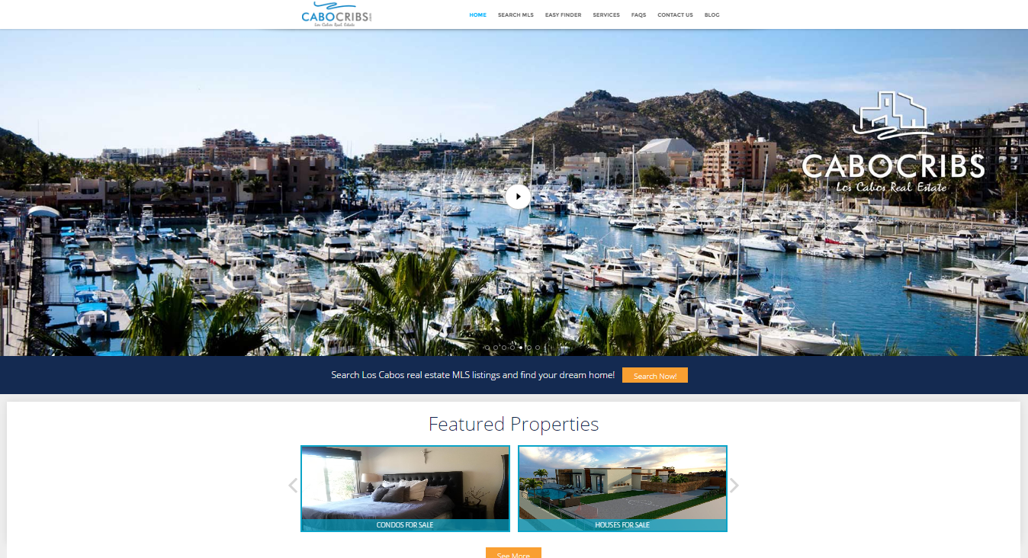
The team is also proud to announce that CaboCribs.com is one of Los Cabos’ only true MLS database websites. With real-time information updates directly coming from the MLS database, CaboCribs.com is exultant to say that if a listing is not listed on the platform, it is a guarantee that the listing is also not on the MLS.
CaboCribs.comalso visions itself to serve as a place where prospective homeowners are guaranteed with quality craftsmanship on the listings of their homes. CaboCribs.com believes that real estate is one of the most valuable assets a person can own so it is right and just that every person a client deals with within the team is qualified; as always, providing informed decisions to clients gets the highest priority. For these reasons, CaboCribs.com gives ongoing training to keep the staff updated about the business. The owner responsibly provides training to already experienced staff to gain a more expert level of skill and knowledge in the real estate business. This only guarantees that all clients will get the best advice and services and the most knowledgeable professional suggestion. This action is a great move that leads to an environment with high standards in the business.
“The team knows that clients come to Los Cabos to relax, enjoy, and indulge in its breathtaking views. Additionally, everyone on the team has a good understandingof the quote, “Every single property is an investment”; which is why a continued servicein providingthe utmost care for client’s hard-earned money from the start of a sale all the way through to the closing and beyond is strictly observed” says Leeroy Jarvis.
CaboCribs.com is currently vetting in more properties that will be offered in the coming months. For more information on these exciting real estate options, visit CaboCribs.com.

About CaboCribs.com
CaboCribs.com, a Los Cabos real estate website that offers a simple solution to finding your dream home; The goal of the website is to make the process of finding a home — or selling your current one — as smooth as possible. For further information, please visit CaboCribs.com

Get in Touch With Us
Address: Local 22 Plaza Cascada
(Blvd. Mauricio Castro 4650)
Zona Hotelera 23400
San José del Cabo, BCS, Mexico

Phone: US: +1-310-860-6063
Mexico: +52 1 624 688 6841
Email: leeroy@cabocribs.com
SOURCE:CaboCribs

