The Rose receives 2016 Jack Kemp Excellence in Affordable and Workforce Housing Award from the Urban Land Institute

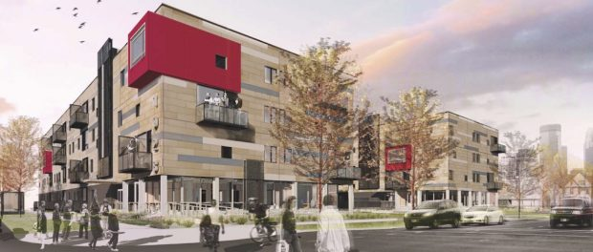
Minneapolis, Minnesota, 2016-Nov-04 — /EPR Network/ — PLACE is pleased to announce that The Rose and three sister developments at Portland and Franklin Avenues (South Quarter) in Minneapolis were selected by the Urban Land Institute (ULI) Terwilliger Center for Housing as the winner of the 2016 Jack Kemp Excellence in Affordable and Workforce Housing Award. This annual award honors developments that ensure housing affordability for people with a range of incomes. Representing the completion of South Quarter, The Rose offers 43 market rate apartments and 47 income-restricted affordable apartments in profoundly sustainable buildings that have neither furnaces nor conventional air conditioning equipment.
In 2010, affordable housing developer Aeon, in partnership with Hope Community, selected PLACE by competition to add specialized development consultant capacity as Sustainability Champion for the last phase of South Quarter. Aeon wanted the final buildings to be the best performing buildings of their kind in the country, on an affordable housing budget. A 501(c)(3) charity dedicated to public benefit, PLACE provided disruptive environmental design analysis, assisted in assembling and facilitating a world-class collaborative design and construction team, deepened community engagement, and refined financial modeling in furtherance of creating high-performance, healthy buildings for Aeon’s residents.
Minneapolis has the harshest climate of any large city in America. The biggest challenge for PLACE was to ensure that the team could deliver a building envelope capable of keeping residents cool in a scorching summer with high humidity and a frigid winter with temperatures plunging to minus thirty degrees Fahrenheit. Buildings in the U.S. are built each day to standards that cause them to consume 70% of America’s primary energy, with 52% of that energy going to heating and cooling. The Rose is 75% more energy efficient than local standards require, which also deepens affordability for residents; it represents PLACE’s most cutting edge restorative development work to date.
“This project is on the leading edge of workforce housing development and preservation,” said J. Ronald Terwilliger, chairman of Terwilliger Pappas Multifamily Partners in Atlanta. “It has it all—mixed-income housing, environmental sustainability, long-term affordability, and long-term financing.”
“The efforts of Aeon and Hope Community, with their many public and private sector partners, prove that previously disinvested communities can point the way forward for mixed-income, environmentally sustainable redevelopment in our cities,” said Stockton Williams, executive director of the ULI Terwilliger Center.
PRESS CONTACT
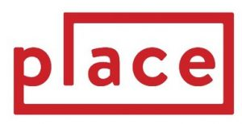
Chris Velasco
Executive Director
PLACE
100 Portland Avenue South
Suite 100, Minneapolis, MN 55401
(612) 309-3889
www.welcometoplace.org
Press release distributed via EPR Network (http://express-press-release.net/submit-press-release.php)

