Oprah’s ‘2016 Favorite Things’ List Draws Global Attention to 10-month old Startup, Urban Agriculture

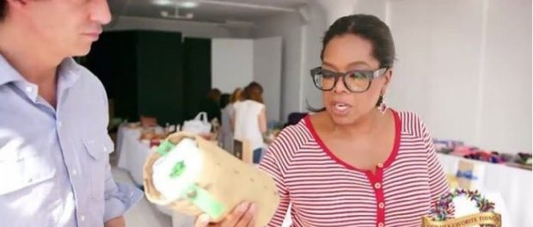

Grow kits in recycled tea bags equip city-dwellers with tools to make their home a garden – starting with only a window ledge
Los Angeles, CA, 2016-Nov-15 — /EPR Network/ — The approach of Black Friday means it’s time for another tradition launching the holiday shopping season – one that is key to the success of a unique group of retail businesses each year. The most watched, and now read, feature from Oprah Winfrey since the early 1990’s, “Oprah’s Favorite Things,” aka “The O-List,” is notable this year for its inclusion of a 10-month old start-up, Urban Agriculture, amongst curated gift suggestions to be included with discounts for the December issue of “O, The Oprah Magazine.”
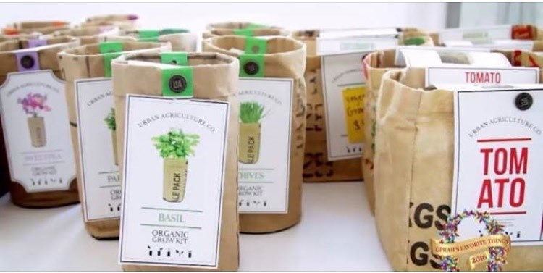
The Urban Agriculture Company designs grow kits that simplify the process of city gardening by providing users with everything needed for a fun and easy growing experience. What has become known as “The Oprah Effect” refers to financial impact of consumers who covet the things Oprah loves, and Urban Agriculture’s grow kits are so revered by Winfrey and her editors that they are listed in the top ten of this year’s “O-List.”
Founder and CEO Chad Corzine is still in his twenties, living in Los Angeles. This time last year, The Urban Agriculture Company was only a seed of an idea. Corzine was working in organic product development and became frustrated how green spaces are hard to come by for many people, noting how the city tends to squeeze out nature.
Deciding to make a lifestyle change of his own, he committed to a healthier diet, exercise and weight loss. Corzine was soon inspired to step away and launch his own consumer product-line, realizing that when the freshest foods are those arriving by truck, a healthy lifestyle feels a long way off.
“As a young, aspiring entrepreneur, to have someone with Ms. Winfrey’s magnitude, reputation and global influence elevate a company like mine is just incredible. My goal is to allow others to make the lifestyle change I had undertaken myself as a city dweller,” said Urban Agriculture founder and CEO, Chad Corzine. “We give you the tools to make your home a garden, even if you only have a window-ledge. From grow-bags bursting with organic vegetables for your table, to crisp herbs for freshening up your cocktails and even outdoor games, we take care of everything you’ll need – making your green adventure easy, simple and fun.”
All of Urban Agriculture’s grow kits come with one pack of organic seeds, one balanced bag of organic soil and one container to grow the plant in. The containers are made from 100% recycled tea bags allowing for perfectly drained and aerated soil, in addition to a uniquely urban look. The Urban Agriculture Company offer a variety of flowers, cooking herbs and vegetables to help urban dwellers have a well-rounded garden.
Video: https://www.instagram.com/p/BMW2abRjFeI/
— End –
The Urban Agriculture Company
https://www.urban-agriculture.net/
The Urban Agriculture Company
2410 E. 38th St., Los Angeles 90058
(p) 323.584.6995
For wholesale inquiries, contact valerie@urban-agriculture.net.
For Press or Media, contact Alex@TransatlanticEnt.com, 415-361-7995
~~~~~
Press release distributed via EPR Network (http://express-press-release.net/submit-press-release.php)

