Christmas Around The World music CD

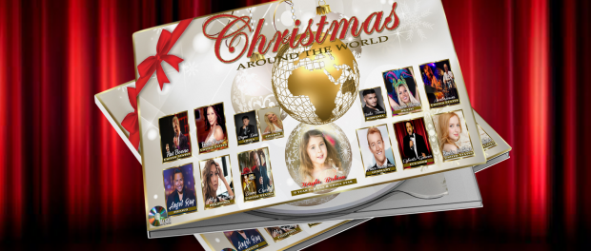
Four (4) generations of international music artists, from 9 countries around the world, performing your favorite Christmas songs in English & their native languages, including some NEW original Christmas songs, on a never before undertaken magical Christmas Music CD!
Northridge CA, 2016-Dec-20 — /EPR Network/ — The Paris5000 Media Entertainment Group and Paris5000 Music & Film Production Company are extremely proud, to release their “Christmas Around The World” CD. Consisting of 14 music artists/singers, from around the world, spanning four generations of talent, this CD is sure to be a collector’s item. The music has been wonderfully arranged and mixed, by industry professional, multi-instrumentalist, music composer/producer, Michael “Mickey” Durio. From Motown To Christmas Town.
Amazing singers like Pat Boone, Dave Crosby ( The Grandson of Bing Crosby), Ambrosia, Freda Payne, Mario Max (Germany), Egberto Garcia (Ecuador), Kayla Bohan (China), Abby Cubey (Philippines), Angel Ray (Mexico), to name but a few of the artists on this magical Christmas CD.
A portion of all sales proceeds will go to support MusiCares, Safe Passage and Make-A-Wish – Greater Los Angeles Chapter.
The “Christmas Around The World” music CD is available online on the Paris5000 special Christmas website: www.christmasmusicstars.com, Amazon.com, under Christmas Around the World CD 2016, and soon ITunes. Sales begin immediately!!
MEDIA CONTACT:
Russ Neibert
Paris Media Ent.
Phone: (818) 251-0641
Office: (818) 833-1905
parismedia5000@gmail.com
Press release distributed via EPR Network (http://express-press-release.net/submit-press-release.php)

