Model at the age of 90 – Genia Galberstadt, a holocaust survivor and one of the first jewish ghetto uprising fighters, dreams of being a model at her 90th birthday

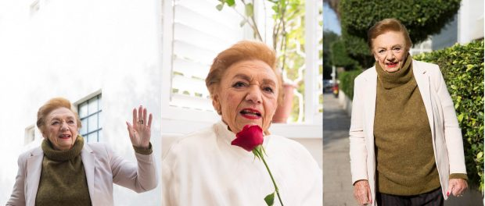
Tel Aviv, Israel, 2016-Dec-28 — /EPR Network/ — Genia Galberstadt (Born Gittel Drebsky) celebrated her 90th birthday on December 25th. Her biggest dream for this birthday was being a model, looking “pretty and young” for her birthday.
Ms. Galberstadt is a fighter in her body and soul. She has been part of the first jewish ghetto uprising in Lakhva in 1942 and was shot in her shoulder trying to escape the Nazis. Later on she found her sister and emigrated to Israel to start her own family. In the last years she faught cancer and won the fight while raising a family of 2 daughters, 3 grandchildren and 2 great-grandchildren.
To make her birthday wish come true, the entire family came together with a team of stylist, make up artist and professional photographer and produced a fashion photoshooting day at Ms. Galberstadt home in Tel Aviv. The photoshoot featured items from H&M winter collection.
If you want to help make Genia’s dream come true feel free to publish the photos or contact Roy Cohen for interviews, high resolution photos and further information.
Contact-Details: Roy Cohen, +353-877979103, israeltimes@gmail.com
Press release distributed via EPR Network (http://express-press-release.net/submit-press-release.php)

