“Your Best Age Now” by Dr. Robi Ludwig Redefines Middle-Age
Nashville, Tennessee, 2017-Jan-20 — /EPR Network/ — Dr. Robi Ludwig’s book Your Best Age is Now, gives insight about how to rediscover personal vibrancy and growth during mid-life.
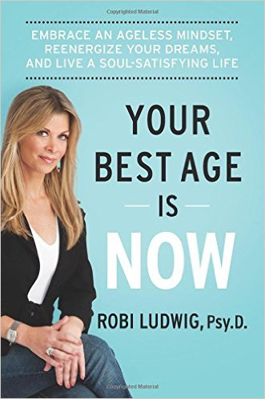
Your Best Life is Now by Dr. Robi Ludwig is more relevant to the middle-aged woman today than ever. With careers, families, and the demands of life, women in their middle age are re-framing this period of their life. We live in a youth-obsessed culture where we fear that our best days are slipping away from us. Dr. Ludwig flips this notion on its head. Middle age has gone from something to avoid, to an era of personal rebirth and reevaluation.
Your Best Age Is Now provides the guidance you need to reject the status quo, become more “you” than ever before, and find the kind of happiness you never thought possible. This book is pertinent for those in mid-life, but also applicable to all stages of life.
“In this revolutionary and riveting book, Robi Ludwig brilliantly helps women break through the disabling myths we’ve been fed about mid-life. She redefines it, using science and inspiring stories from her practice, empowering us to enjoy this truly fantastic time of life.”
-Lisa Bloom, civil rights attorney, legal analyst for NBC News and Avvo.com, and New York Times bestselling author of Think.
Dr. Robi Ludwig is a nationally known psychotherapist and award-winning reporter. She has been appearing in broadcast media since 1997 and is sought after for her psychological insights on a wide range of topics. Dr. Ludwig has experience in counseling people with depression; she has treated all forms of mental illness, substance abuse, grieving, sexual identity issues, job stress, emotional and sexual abuse problems as well as the more common social and parenting issues.
Dr. Ludwig’s academic credentials include a doctorate in psychology (Psy.D) from California Southern University; she holds a post-masters certificate in advanced clinical work from Hunter College, a master’s degree in social work from the University of Pennsylvania and a bachelor’s degree in mass communications from Cedar Crest College. She lives in New York with her husband and two children.
Contact-Details:
Mark Turner
mark.turner@abramsartny.com
Press release distributed via EPR Network (http://express-press-release.net/submit-press-release.php)

