Global Resource Coin

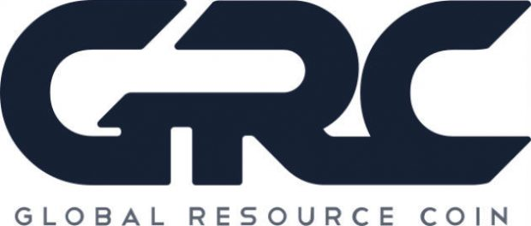
PRAGA, Czech Republic, 2017-Feb-14 — /EPR Network/ — GRC is the first cryptocurrency aimed at casual users who want to get investment resources. Cryptocurrency was developed in 2013. After a registration procedure and a creation of a special licensed trading platform, it was launched at the beginning of 2017.
International producers and developers of minerals and natural resources showed their interest. So the GRC company introduced proprietary cryptocurrency code valid until 2018. It’s aimed to secure the mining process and users’ activity from possible hacker attacks. In 2018 cryptocurrency trade will be deployed on the world’s largest stock- and commodity exchanges, such as NASDAQ.
The head of the group of GRC’s cryptocurrency creators is Tomas Beran, Czech developer from a famous family of Beran’s billionaires. At the end of 2016 world media wrote about the start of operations on the trading platform using GRC’s cryptocurrency.
Global corporations and governments do not allow ordinary people engage in natural resources investment. They need to have a considerable amount of money, a financial education and a special license. Since GRC’s trading marketplace has a specialized license, anyone can invest savings in a particular natural resource. Cryptocurrency acts as an intermediary between users from all over the world.
GRC is the first cryptocurrency based on natural resources. Our platform helps to cut investment risks, offering the most relevant sources of income. GRC’s platform specialists analyze the offers on the natural resources markets. They select only the most relevant ones for our users. This way, each one can take advantage of the offers that appear daily on our platform.
From the year 2018 GRC expects its cryptocurrency rate to grow due to its social usefulness and relevance. You can use our cryptocurrency not only as a natural resources investment tool, but as a base for a perspective financial future.
Start changing your life right now and register on the GRC platform.
Media Contact
Global Resource Coin
https://grcoin.eu/
Press release distributed via EPR Network (http://express-press-release.net/submit-press-release.php)

