“Questionable Minds,” a New Book: Conversations with Writers about Writing
OTTAWA, Ontario CANADA, 2017-Feb-15 — /EPR Network/ — The mind of a writer is a mysterious place. In Questionable Minds: conversations with writers, social psychologist dr george pollard gives a guided tour of the creative mental landscape of writers. In this unique collection of conversations, dr pollard explores the making of a fictional story or a stand-up comedy routine.
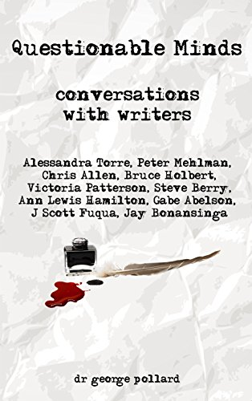
If you’re curious how your favourite novel or stand-up comedy routine comes into being, Questionable Minds helps you find out. This new book helps answer many questions. Where do the ideas come from? How do authors develop their characters? What is the secret of writing a successful stand-up comedy routine?
In this eclectic view of the workings of the imagination; dr pollard has assembled a remarkable panel of writers, covering a wide of range of literature. The conversations, in this collection, are with writers of thrillers, satire and westerns, as well as stand-up comedy.
Alessandra Torre tells gripping tales she claims are erotica. Peter Mehlman, a pillar of Seinfeld, has an idiosyncratically ironic eye and smooth, easy writing style. Chris Allen trades in thrillers that may contain more than a hint of truth.
Bruce Holbert is the thriftiest of writers, building finely honed sentences. Victoria Patterson artfully skewers the upper class, of Orange County, California. Steve Berry creates intricate mysteries against a backdrop of notional history. J Scott Fuqua tells tales with words and illustrations that resurrect a bygone era.
Ann Lewis Hamilton writes serious stories in a shrewdly droll style. Gabe Abelson is the A-list writer of late-night television talk show monologues. Jay Bonansinga writes The Walking Dead novels.
What inspires these writers? How do they develop stories or comedy? Why must they write?
To a one, they agree writing is sweating blood that shows up as squiggles on a page or pixels on an e-reader. Writing fiction or stand-up comedy is not for the easily distracted, the indolent or faint of heart. Writers must be eager to chase their characters and stories down the rabbit hole.
Questionable Minds is notable because of the depth and clarity of the insights found in the conversations. The book exhibits a unique intimacy; there’s no sense of canned answers to a list of prepared questions. Instead these conversations move effortlessly, following lines of curiosity and interest, while drawing out a wealth of detail.
Every writer dr pollard talks with has a different story to tell. Each has his or her own sources of inspiration. Their routines are personal; sometimes fitting writing around the rest of their lives or, for a few, squeezing in time for family, if they can drag themselves away from writing.
It is notable how willingly, candid and freely the writers talk. They discuss in detail the motivations that drive them to write. For some it’s enthusiasm; others want to explore their own lives and, perhaps, reframe them in a different context; still others want to discover what happens to their characters, as the story unfolds and still others simply enjoy the act of writing. Questionable Minds is an inside view of some highly distinctive minds, which are absorbing places to explore.
Although dr pollard explores similar themes with each writer, the conversations never become repetitive. Each writer is too distinctive a personality; each brings something fresh to the conversations and our understanding of why writers write. If you wonder how writers do what they do, this book will show you that it’s much more complicated and enthralling than you may imagine; it will improve your reading experience, too.
Questionable Minds is available through Amazon, in paperback and eBook editions at https://www.amazon.com/Questionable-Minds-Conversations-george-pollard. Review copies, in MOBI format, are available from the author at drgeorgep@questionableminds.com. For more information on Questionable Minds, visit the web site http://questionableminds.com or e-mail, as you wish, perhaps to arrange an interview with dr pollard.
About the Author
dr george pollard is a sociometrician and social psychologist at Carleton University in Ottawa, Canada. His teaching and research interests include the process, practise and effects of writing as an act of fulfilling the pop culture and entertainment need of society as well as media and truth.

Press release distributed via EPR Network (http://express-press-release.net/submit-press-release.php)

