Oregon Grow Cabinets Launches Today – Home Growing, Refined
Bend, OR, 2017-Mar-08 — /EPR Network/ — New startup OREGON GROW CABINETS, launching today, is focusing on the burgeoning home-growing movement with a new suite of grow cabinets constructed to fine-furniture standards and equipped with innovative climate controls. “Our cabinets are an industry game-changer,” says Adam Bronstein, owner/founder. “They are designed to provide you with the perfect customizable growing environment while looking great in your home. Our grow cabinets are something you will be proud to display. There is nothing like our products on the market today and they are built here in Central Oregon.”
People are discovering that they can grow for themselves what they used to buy, and Oregon Grow Cabinets make the home-growing experience streamlined and easy. Whether it’s growing cannabis or vegetables, the climate-controlled growing environment inside an Oregon Grow Cabinet takes the guesswork out of gardening and helps to ensure that your plants thrive. Growing your own also allows consumers to avoid the pesticides and fertilizers used by commercial growers. “Nothing can match the reward of growing and providing for yourself,” Bronstein says. “If you don’t have control from start to finish, how can you really know what you are consuming? I like having the piece of mind of knowing exactly how my crops are grown. It also allows me to focus on the quality of what I grow.”
A zero-compromise approach to form, function and quality all came together during the development of the suite of Oregon Grow Cabinets. “When I decide on making a significant purchase in life, I am looking for products that add value and provide me with day-to-day enjoyment. Like many others today, I’m tired of the cheaply-made, soon-to-hit-the-landfill, often gimmicky products that are being peddled. A fine furniture maker by trade, Bronstein reworked and fine-tuned the cabinet designs for more than a year before it met his high quality standards. He concludes, “I wanted to merge the worlds of indoor growing and furniture making together, and I am proud to launch Oregon Grow Cabinets and bring a beautiful and functional product to market.”
Oregon Grow Cabinets LLC builds high quality grow cabinets for the home in Central Oregon.
Contact-Details:
Adam Bronstein
Product image:

Outside View
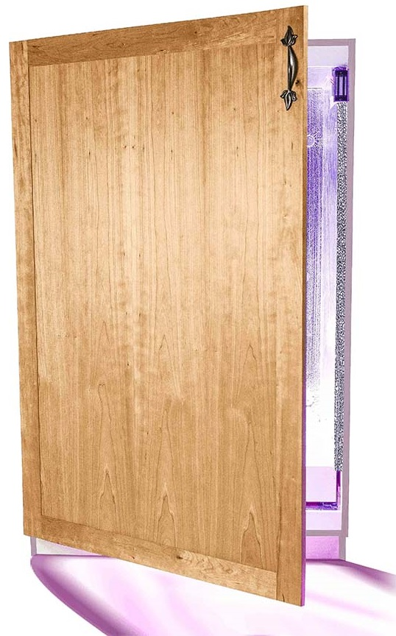
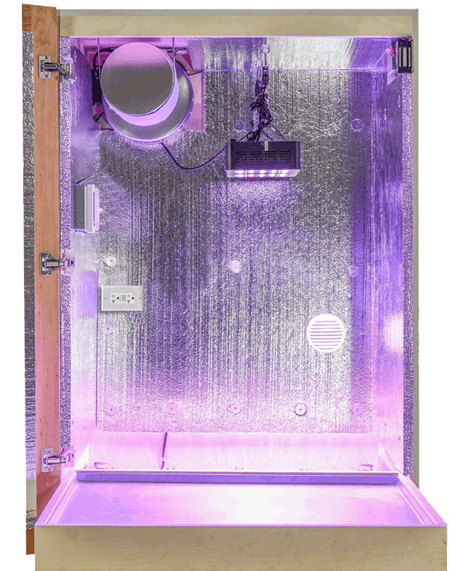
Inside View

