**Behind the Lyric**

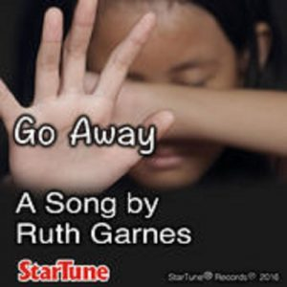Richmond, Texas, 2017-May-02 — /EPR Network/ — “Go Away” A song that is available on itunes and amazon.com was written after the incident where Rapper Fifty cent mocked an autistic man. It was out of empathy for that man intertwined with my own hurt, that this song was written.

I was struggling emotionally and solicited the help of an ex-coworker. Instead of responding in a respectful manner, he berated me. I was in a difficult situation and had ongoing health issues. I reached out believing he would surely help or offer advice, but I misjudged who he was as a person and his response was unexpected.

That was emotionally difficult for me although, I was not publicly humiliated the way Andrew that autistic man was but because of my experience, I could empathize.

That lead to the creation of the lyrics to the song, “Go Away.”

I keep hearing the mean things you said.  
Your words keep repeating, they play in my head.  
I had nowhere to go but you made me wanna hide.  
Because of struggles, many days I curled up and cried.  
Go away, go away, but don’t fill me with shame.  
I’m nothing more than a pawn in your game.  
Go away, go away, I’m just trying to survive.  
But hash words and bullying has claimed many lives.  
I didn’t want to live life locked in.  
You formed your conclusion without question.  
You believed I chose to look the way that I do.  
I didn’t and I wouldn’t choose to behave like you.  
I’m grown up but inside I’m a kid.  
And that doesn’t cause some to bat an eyelid.  
You need to know that’s how it’ll always be for me.  
With Autism, I’ll live and I’ll never be really free.

My hope is that this song might help to curb insensitive obnoxious individuals, and somehow soften the way we respond to others.

Available on line from itunes at (<http://itunes.apple.com/album/id1178363030?ls=1&app=itunes>)  
And also from Amazon.com

Other song and lyrics written by Author Ruth Garnes were carved from love, hurt and sorrow. At times, it was my own, other times, I echoed the pain of the world around me.

A poet and advocate of hurting children, my author’s profile and poetic anthologies are available on line at (<https://www.amazon.com/Ruth-Garnes/e/B00T6H1I2C>)

Contact-Details: Ruth Garnes  
1810 McCrary Rd, Richmond Texas  
713-562-7904 at <https://soundcloud.com/ruth-garnes/garnes-ruth-go-away>  
<https://www.amazon.com/Ruth-Garnes/e/B00T6H1I2C>

Press release distributed via EPR Network (<http://express-press-release.net/submit-press-release.php>)