Jeff Martin (The Tea Party) Produces Exquisite Debut EP for New Australian Indie Duo, Secret Solis, with Terepai Richmond (The Whitlams) on the Drums
Adelaide, Australia, 2017-May-18 — /EPR Network/ — Between sold out tours of Australia and Canada in 2016, Jeff Martin (The Tea Party) invited new Australian indie folk / rock duo Secret Solis to record their debut EP, “Deep Down” at River House Studios near Byron Bay. The sessions produced a five track album of indie folk / rock anthems, the tracks resonating with both Led Zeppelin’s driving acoustic rock and the ethereal ballads of Pink Floyd. Jeff’s eastern palette adds an eclectic flavour to the EP that is reminiscent of his early albums with The Tea Party, as in Splendor Solis and Edges of Twilight. Terepai Richmond (The Whitlams) joins the line up on drums providing a John Bonham / Ginger Baker style foundation for the albums songs.
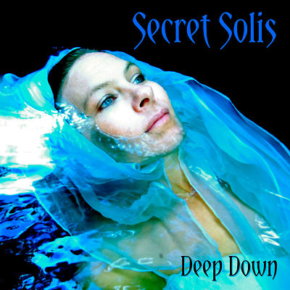
When asked to describe the project Martin says “I have been waiting for years to produce a sound like this at River House Studios. Of all the production work I have done over the last 25 years, including my work with The Tea Party, Secret Solis’ EP “Deep Down” is in the top five of work that I am most proud of.”
Secret Solis was formed in 2012 when established Cairns-based singer/songwriter, Kian Eder met Cally Pysden, a pianist and singer/songwriter from Adelaide. Before meeting Cally, Kian’s music was heavily influenced by Pink Floyd, The Tea Party, A Perfect Circle, and acoustic rock cross-over artists like Ben Harper. Collaborating with Cally added a new dimension to Kian’s vision, elevating the music to new heights with her soaring ethereal vocals the likes of Enya, Dido, Sia and Amy-Lee. Enter Jeff Martin as producer and musician using production techniques straight out of Jimmy Page’s playbook, and Terepai Richmond (The Whitlams) on drums and you have a special magic happening in the mix.
Martin agreed to produce the band after hearing only a small section of their demo, “Speechless Soul” and the rest is history. Jeff plays all the heavy guitars and solos, hurdy gurdy and synths including his boutique theremin. He also lends his voice to the band’s debut single, “Sunshine”. The second single, “Are You Listening?” features Jeff playing an old school rock solo unlike many have ever heard.
Both singles are now available at secretsolis.bandcamp.com
When asked what the songs are about Kian says “The songs are based on our personal experiences but ultimately we are aiming to create relatable themes that resonate with everyone. We want this music to heal, uplift and empower people to face and overcome the many challenges of life as our favourite music has done for us.”
The Debut EP “Deep Down” will be released via bandcamp on the 16th of June, 2017.
Secret Solis are currently seeking expressions of interest from record labels, managers and booking agents to take the project to the next level.
Secret Solis EPK
“Beautiful, warm and rich vocal harmonies. Makes me feel like crying, dancing and laughing. These guys really have something.” – Producer, James Sanger (Dido, Sinead O’Connor, Annie Lennox, U2, The Cure, Madonna)
Contact-Details: Company: Secret Solis
Contact: Kian Eder
Phone: +61 4 3152 2362 // +61 8 8956 2955 // +61 8 8956 8956
Website: secretsolis.com
EPK: http://onepagelink.com/secretsolis/
Sales: https://secretsolis.bandcamp.com/
Facebook: https://www.facebook.com/secretsolis/
Email: music@secretsolis.com

Press release distributed via EPR Network (http://express-press-release.net/submit-press-release.php)

