New Experiment Reveals ‘DNA of the mind’: Mystery Of Human Intelligence Solved
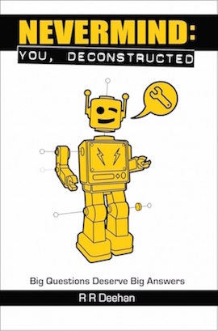
LONDON, UK, 2017-Jul-19 — /EPR Network/ — A solution to the ‘hard problem’ of human consciousness has finally been found, explaining how our minds work. In his new book, ‘Nevermind: You, deconstructed’, British author R R Deehan provides a simple and testable answer to a question that has long puzzled scientists and philosophers:- how do our minds bootstrap their way to consciousness? According to R R Deehan, “The answer was right under our noses all along, and it’s incredibly obvious, once you know what to look for.”
Older theories, such as the idea that humans possess ‘souls’, or that our minds somehow result from quantum effects, have failed to solve the hard problem, usually because they can’t be tested. In ‘Nevermind: You, deconstructed’, R R Deehan offers a short series of easy thought experiments that anybody can perform from the comfort of their own armchair. These experiments lay bare the secrets of your own mind and allow you to witness firsthand exactly why there’s a ‘you’ hovering inside your head, and what it’s capable of.
DNA is a four-letter chemical alphabet from which all living things are built, but the mental equivalent is even simpler, consisting of just three components that combine in straightforward ways to produce every aspect of your mind. The implications for this discovery are immense, and include a workable blueprint for a truly self-aware artificial intelligence based on the human model, as well as new ways to look at all the other ‘Big Questions’, such as ‘which came first? Consciousness or the universe’? With such notables as Stephen Hawking and Elon Musk warning about the possible dangers of artificial intelligence, ‘Nevermind: You, deconstructed’ offers a way to ensure we don’t accidentally open a Pandora’s Box of uncontrollable technology that could cause our own extinction.
About R R Deehan
R R Deehan graduated from The London School Of Economics, and went on to become involved in artificial intelligence as far back as the 1980s. His unique combination of skills provided the insight that became ‘Nevermind: You, deconstructed’, available from the website http://rrdeehan.com
Contact-Details:
R R Deehan
Suite B, 16 Floral St,
London WC2E 9DS UK
07599 953010
Press release distributed via EPR Network (http://express-press-release.net/submit-press-release.php)

