Travel To Kenya Safari Destination and Nairobi Tours, Trips and Attractions

Nairobi, Kenya, 2017-Aug-12 — /EPR Network/ — The Magical Kenya is still on – Restoring the Tourism confidence in Kenya as a hub of Both Business and Leisure Travelers.
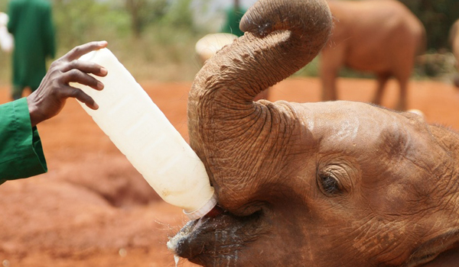
Holidays are everybody’s ideal way to relax and see the world. As our guests get to experience the wildlife and other products we have to offer such conservation is of out most important. We support conservation by preferring to prioritize Eco-lodges and thereafter the other camps and Budget Camps as well.
The Amboseli National Park is very near Nairobi about 3 hours drive one way. At these eco-facilities you will be able to learn more about how important they are to secure the existence of the local environment and how you are directly helping the local community by choosing to stay in such an accommodation.
Nairobi City Tours
Nairobi National Park Tour
Lake Nakuru National Park Tour
Full Day Nairobi Tour to National Park, Karen Blixen, Giraffe center
Elephant Orphanage Tour from Nairobi
Flying Packages to the Masai Mara National Park
Governors Camps
Kichwa Tembo Tented Camp
Mara Interpids Club – Explorer
Kenya Elections
Kenya has just concluded its General Election in August, 2017. The tourism industry is set to compensate in the coming months from setback of negative reporting especially from international media channels. In some instances this is not the true state on the ground and only affects some areas cluster and NOT the whole country. Most tourist visited areas are not affected. We urge travelers to seek clarification from credible sources of the Kenya Foreign Missions in their Home country or Ministry of Foreign affairs of Kenya. However, we are optimistic that the work done in the past by Hon. Najib Balala and his teams all over the world will not decrease but increase in the coming months and years.
Popular Nairobi Tours, Trips and Attractions
Nairobi National Park Tours gains popularity with transit travelers and conference delegates in Nairobi, Kenya. Nairobi is a hub of meetings and conferences almost every week there are numerous meetings and conferences taking place. The Nairobi National Park Tour offered by Cruzeiro Safaris has impressively gained popularity. Being an hourly tour delegates and travelers on transit see it as valuable time spent with the limited time they have in Nairobi.
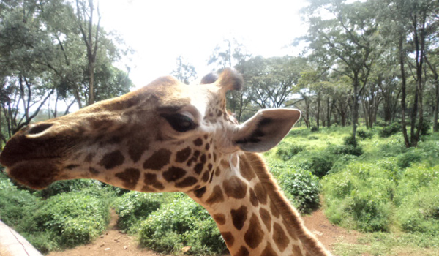
Cruzeiro Safaris has several hourly tours but the Nairobi National Park Tour with affordable prices has proved to be the top ranking and it’s forecasted to be till the end of the year. Nairobi National Park is home to many species of wildlife including endangered black rhinos, lions, leopards, cheetahs, hyenas, buffaloes, giraffes and diverse bird life. Nairobi’s skyscrapers can be seen from the park. The Nairobi Tour is offered two times a day making it easy for delegates to book pre and post conference time and traveler on transit to manage their pick up and drop off times effectively. The timings are said to be early morning at 6am and 2pm depending on location of guest hotel. Morning tours are said to be more productive than afternoon however one can choose according to the time available for the guest. Single travelers often have a problem because most of the tours are available for a minimum of 2, (however, they pay less the 2nd persons park entry fee) then they are assured of the tour. It’s also important to send an email or call to ask if there is a group to join any number to use +254722370833 or +254710729021 or visit – https://cruzeiro-safaris.com/nairobi-national-park

ABOUT US:
Cruzeiro Safaris Kenya Limited is a tours and travel company based in Nairobi, Kenya. It’s mandated to provide tours and safaris to everyone willing to be enlightened about travel destinations priority being Kenya then other countries.
Contact-Details:
Claudia Kabui
Cruzeiro Safaris Kenya
www.cruzeiro-safaris.com
info@cruzeiro-safaris.com
Tel: +254-722-370833 or +254-710-729021
Mumias South Road, Buru Buru Shopping Center, Visions Place

===
Press release distributed via EPR Network (http://express-press-release.net/submit-press-release.php)

