The Certified Angus Beef® brand honors retail, distributor stars

NASHVILLE, Tenn., 2017-Oct-05 — /EPR Network/ — As consumer demand for great-tasting beef continues to grow, retailers play an important role in satisfying their needs. Retailers and distributors were recognized by the Certified Angus Beef ® brand for their leadership in product quality, marketing and sales at the group’s annual conference in Nashville on Sept. 27-29. Brand partners, including meat processors, distributors, chefs, retailers and cattle ranchers, gained strategies to nurture their focus on delivering premium beef to consumers.
“Quality and integrity unite their focus on delivering the finest beef,” says John Stika, the beef brand’s president. “They are stars in their markets for bringing the Certified Angus Beef ®brand’s ranching heritage and focus on quality and integrity to their customers, and ultimately, consumers.”
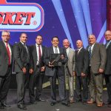
- DeMoulas Market Basket, Tewksbury, Mass., earned the Retailer of the Year The retailer offered bold product features, generous point-of-sale displays and team training to provide customer assistance at the meat case. Through the retailer’s all-around focus on quality and value, DeMoulas also received the Top Retail Sales Volume Increase award.

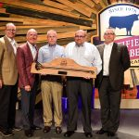
- K-Va-T Food Stores, Abingdon, Va., was named Retail Large Chain Marketer of the Year. Food City chefs share beef recipes on television shows to bring fresh ideas to customers. Promotions, like Fresh Fridays, encourage trust in Food City’s dedication to quality and service.

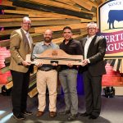
- Cermak Fresh Market, Chicago, Ill., received the Retail Small Chain Marketer of the Year Cermak excels at serving customers with fun promotions and attention to detail. Training at the Certified Angus Beef ® Culinary Center energized the team for a meat manager contest that helped Cermak also receive Top Average Volume Retail Store with more than 10 stores.

- Longo’s, Vaughan, Ontario, was recognized as the International Retail Marketer of the Year. Beef 101 training for Longo’s meat managers supported a successful summer promotion. Cooking classes and ads in the retailer’s Experience magazine also offered beef meal solutions to customers.

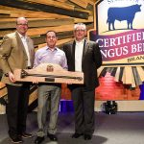
- Caraluzzi’s, in Bethel, Conn., is the Independent Retail Marketer of the Year. Caraluzzi’s has grown over the past two decades with the Certified Angus Beef ® brand in three stores. They offer the brand’s Prime, Natural and deli meat items for the ultimate selection of superior quality.

- Angus Best, Hermosilla, Sonora, Mexico, was presented the International Retail Independent Marketer of the Year Angus Best dedicates its entire meat case to the brand, displays signage storewide and posts billboards. The retailer’s grab-and-go meat case offers beef cuts for easy dinners.

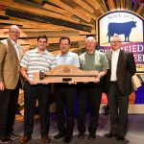
- ShopRite, Edison, N.J., earned the Retail Value-added Products Marketer of the Year ShopRite offers a wide selection of premium beef items in the deli case and has ready-to-prepare meals. Frequent product features, social media posts and videos give customers more dinner ideas.

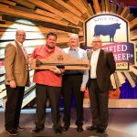
- Gelson’s, Encino, Calif., received Retail Brand Extension Marketer of the Year Gelson’s excels at marketing the Certified Angus Beef ® brand and the brand’s Prime products. Seasonal promotions, product sampling and social media interaction explain product quality to shoppers.

- Quality Food Centers, Bellevue, Wash., is the Retail Social Media Marketer of the Year. QFC used online contests, coupons, the brand’s Roast Perfect app and meat staff selfies to connect with customers. Food blogger events shared holiday roasting ideas to coincide with roast promotions.

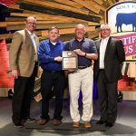
- Weis Markets, Sunbury, Pa., was named the Retail Rising Star. Weis Markets focused on the brand in its Fresh magazine and offered six items in the circular every week. Through social media posts and training, the team shared its pride in its beef offerings.

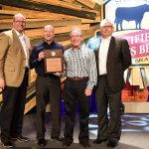
- Associated Retail Operations, in Salt Lake City, was recognized as the Retail Rookie of the Year. Associated Retail powered up promotions to launch the brand in stores. Weekly features and in-store videos led customers to the meat case, where staff were trained in beef knowledge to assist them.

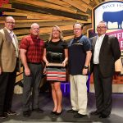
- Meijer, based in Grand Rapids, Mich., earned Top Volume Large Chain Retailer. Meijer excelled at marketing the brand in stores, at community events and through a comprehensive digital campaign. Success is guided by ongoing training of their meat managers and specialists.

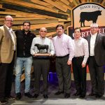
- H-E-B Mexico, Escobedo, Nuevo Leon, is the Top Volume Small Chain Retailer. H-E-B secured growing sales through extensive promotions online, on billboards, in television appearances, with in-store product sampling, in local lifestyle magazines and every week in its own publication.

Additional companies recognized for their success and dedication to offering Certified Angus Beef ® brand products were:
- Crest Foods, Edmond, Okla.: Top Average Volume per Store, with fewer than 10 stores
- Dekalb Farmers Market, Decatur, Ga.: Top Volume Single Store Retailer
- Topco Associates, Elk Grove Village, Ill.: Top Volume Cooperative
- Associated Wholesale Grocers, Oklahoma City: Top Volume Retail Distributor
About the Certified Angus Beef ® brand
Founded in 1978, the Certified Angus Beef ® brand is the original, and the best, brand of Angus beef, which got its start when a group of family ranchers set out to create a brand of beef that delivers superior taste and tenderness. Today, the Certified Angus Beef ® brand remains true to its roots, providing consumers with superior beef through a gate-to-plate network of family ranchers, chefs and retailers worldwide. Renowned for its exceptional quality, each cut meets 10 exacting standards to make it more selective than USDA Choice and Prime. For more information, visit CertifiedAngusBeef.com, or look for the brand on Facebook, Twitter, Pinterest, Instagram and LinkedIn.
Editor: Click on links for downloadable, print-quality photos and videos.
More award information available at: http://www.certifiedangusbeef.com/press
Contact:
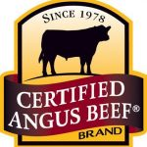
Crystal Meier
Certified Angus Beef LLC
330-345-0427
cmeier@certifiedangusbeef.com

Press release distributed via EPR Network (http://express-press-release.net/submit-press-release.php)

