M. Davis & Sons Acquires Val-Tech Inc.

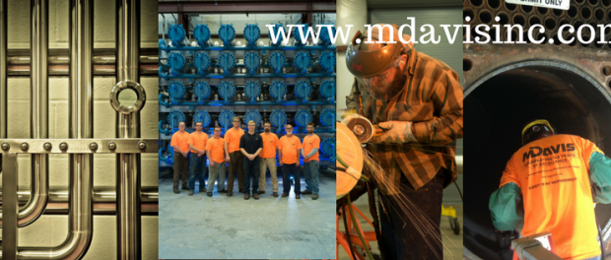
Wilmington, DE, 2017-Oct-17 — /EPR Network/ — M. Davis & Sons, Inc. announces the recent acquisition of Valtech, Inc., a manufacturer of VTi Power Distribution Equipment. M. Davis will continue the manufacturing and sale of this equipment under the new brand name “VTi by M. Davis”.
The types of power distribution equipment that will be manufactured at the Newark, Delaware facility located at 24 McMillan Way are Portable Power Distribution Equipment (PPDC), Fused Distribution Panel (FDP) and Unitized Distribution Substation (UDS). The UDS equipment is the main product that is currently produced.
The UDS equipment is utilized by engineering firms, plants and facilities due to their smaller footprint. “Facilities that have space constraints are looking for the UDS because of the compact footprint and the ability to distribute local, clean power” stated Edward J. Harrison, Project Manager for the VTi by M. Davis production facility. Additionally, the UDS equipment is customizable for color and accessories such as lighting contactors and heat trace EPD breakers.
M. Davis & Sons, Inc. has fabricated custom process control panels for years at the 200 Hadco Road, Wilmington, DE location. The addition of the VTi by M. Davis product line is an introduction into the power distribution market. “The VTi by M. Davis production business compliments the existing custom process controls panel shop,” says CEO Peggy Del Fabbro.
About M. Davis & Sons, Inc.
M. Davis & Sons, Inc. is a fifth generation woman-owned mechanical/electrical contractor and fabricator based in Delaware. M. Davis & Sons has all of the in-house service capabilities to handle the entire scope for the customer to expedite a quality project. For more information, visit www.mdavisinc.com. For more information about VTI by M. Davis, visit www.vt-inc.com.

# # #
Contact-Details: M. Davis and Sons, Inc.
Contact: Elaine Buonopane
Email: elaine.buonopane@mdavisinc.com
Phone: 302-993-3365
Website: www.mdavisinc.com
VTI by MDavis website: www.vt-inc.com
Address: 19 Germay Drive, Wilmington, DE 19804

Press release distributed via EPR Network (http://express-press-release.net/submit-press-release.php)

