Travel to Africa this Holiday season on a wise budget friendly Nairobi tours and Kenya Safari Packages
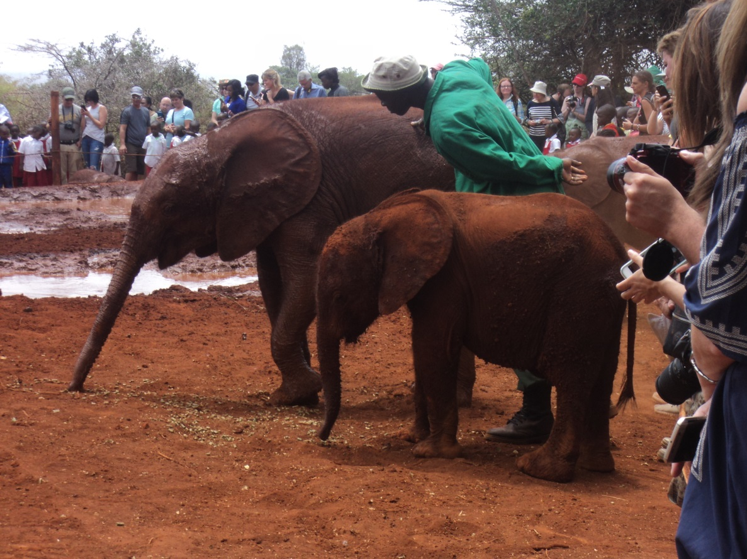
Nairobi, Kenya, 2017-Nov-02 — /EPR Network/ — Budget travelers are increasingly looking for holiday destinations on the internet opting to join other people for any Kenya safari package. Most Tourists use price as a major factor in deciding which safari company to use thus the idea to share the costs.
Over the past 8 months it has been reported that there has been an increase of requests by single and budget travellers on shared Safaris. Group bookings arranged to make travel and accommodation cheaper for tourists in Kenya have dominated this safari option, the groups are encouraged to charter planes at reduced airfares from Europe to Kenya to come and join Safari Ndovu 6 days safari package.
Featuring of the Safari Ndovu 6 day safari package by Cruzeiro-Safaris.com is a pocket friendly safari incorporating 2 national parks that is Amboseli National Park and Lake Nakuru National park, 1 game reserve Masai Mara National Reserve and 1 popular eatery attraction that is the carnivore restaurant in Nairobi. It is important for tourists to know the different wildlife terminologies used in Kenya such as National parks, game reserves and sanctuaries found in Kenya.
National Parks are set up and controlled by the central government. They are established by an Act of Parliament or through legal notice by the Minister concerned, in the government gazette. Its boundaries or existence can only be altered by similar legislative action. National Parks are managed and controlled by government agencies. The agencies collect entry fees to the parks, take care of the animals and assist in resolving the people animal conflict.
The Safari Ndovu 6 day Safari package visits 2 (two) of these National Parks namely Amboseli and Lake Nakuru National Parks.
Other Important National Parks are:
- Nairobi National Park tour in Nairobi
- Amboseli National Park Day trips from Nairobi
- Lake Nakuru National Park Full day trip from Nairobi
- Aberdares National Park Safaris from Nairobi
- Tsavo East and Tsavo West Tours and Safaris from Mombasa
Other attractions in Nairobi
- Elephant Orphanage Tour in Nairobi
- Giraffe Center and Karen Blixen in Nairobi
- Nairobi City Tour, national museum plus lunch
National Game reserves or National Reserves are set up and managed by the local authority where it is located. The local communities interact freely with the wildlife before such an area is declared a game reserve. Unlike National Parks, the local communities are allowed to live and graze their animals in game reserves. For example, the Maasai people live and graze their animals in Masai Mara without being restricted by the management of the park. Game reserves may also be set up and owned and managed by private individuals with special permission from the Central Government. In Laikipia district, there are several game reserves that are privately owned and fenced off from the public. The Government has little control over what takes place in the privately-owned game ranches. Whereas the government has banned game hunting, animals in privately owned ranches are slaughtered to provide game meat to major hotels in Nairobi and Mombasa under licence from the Central Government.
Wildlife Sanctuaries are areas that have been set aside for the protection of specific animals or birds if they are considered endangered for one reason or other. In an environment where elephants are threatened by poachers for example, a protected area is established and fenced off to host only elephants, where they are cared for and secured. Such an area is called an elephant sanctuary such as the Mwaluganje National reserve in Kwale District. The Safari Ndovu – 6 days package does not visit any sanctuary, however at Cruzeiro-safaris, one may request for a tailored safari to the Sweet Waters Sanctuary caring for Chimpanzees or any other Sanctuary.
Other safaris located in the best game drive view places
- Mount Kenya and Masai Mara Safari by Road and Flights for 9 (nine) Days
- Luxury Travel to the best choice of hotels and lodges in Kenya
- Governors Camp in Masai Mara Safari package for 4 (four) Days flights
The one eatery attraction in the Safari Ndovu – 6 days safari package itinerary is called the Carnivore Restaurant in Nairobi. Guests on the Amboseli National Reserve 3 days package safari or Lake Nakuru & Masai Mara 4 days package safari may join in or drop off on pre-organised group tours after a sumptuous meal at the Carnivore, featuring various kinds of game meat. Carnivore is also known as the meat eaters’ paradise.
Shimba Hills Tour from Mombasa and Diani
One of our guests from Russia who travelled to 1 park and 1 reserve had this to say on our trip advisor page:
Lake Nakuru & Massai Mara My wife and me spent 4 days at Lake Nakuru and Maasai Mara Sopa lodges with Cruseiro. The pick up/drop off from NBO airport.
I like the concept when Cruseiro gives you the mini-bus with a driver who is also a very good guide and who always stays with you during your Safari. The driver/guide is absolutely flexible for you to get maximum pleasure from your trip. The mini-bus hasn’t been very comfortable but nearly all Kenyan safari operators use this type of Toyota vans as it’s realistically very reasonable for Kenyan roads.
Lake Nakuru lodge has a very picturesque location. We could watch rhinos fighting in 20 meters from our lodge window. Maasai Sopa although had much better kitchen. The only negative impression was extremely noisy neighborhood – Chinese in lake Nakuru and north American in Maasai Sopa.
Special thanks to our very experienced guide and driver Simon. We enjoyed his gentleman manners and good sence of humor. Simon did his best to please us up to the end of the trip. Besides, Simon has a very good feeling of where to go to see the best of the wild life. Many thanks to Andrew and Claudia as well. It was a great experience for us!
About cruzeiro-safaris.com
Cruzeiro-safaris.com is established in Kenya, incorporated in 2004. Its core business is safari packages and day tours complemented by air travel. It has a well established wealth of experience in arranging memorable tours and safaris and has established a client base who provide with repeat business year after year. Join us on facebook, twitter and youtube. Safaris in Kenya may be tailored to the tourist taste and can extend to Tanzania and Uganda.
Contact-Details: For further information and reservations, Contact;
Claudia Kabui
Email: info@cruzeiro-safaris.com
Website: | https://www.cruzeiro-safaris.com
Mobile : +254-(0) 722-370833 (Kenya)
Sales: + 254 (0) 710-729021 (Kenya)
===
Press release distributed via EPR Network (http://express-press-release.net/submit-press-release.php)

