Fashion & Invites: Women’s Fashion Trends and Exclusive Fashion Sale Codes at fashionandinvites.com
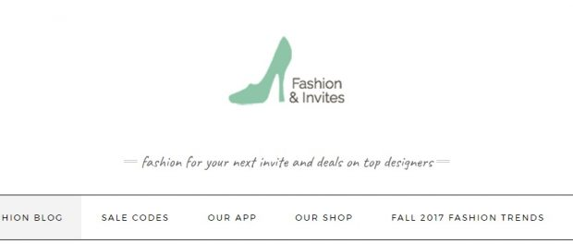
Long Branch, NJ, 2017-Nov-07 — /EPR Network/ — By displaying thousands of trendy clothing items and accessories, providing articles on current fashion trends, featuring top designers, and including ready-to-use exclusive sale / discount codes for designer styles and top stores – the Fashion & Invites blog, helps you stay up-to-date on women’s fashion trends while providing discounts to more comfortably purchase top fashion designer styles.
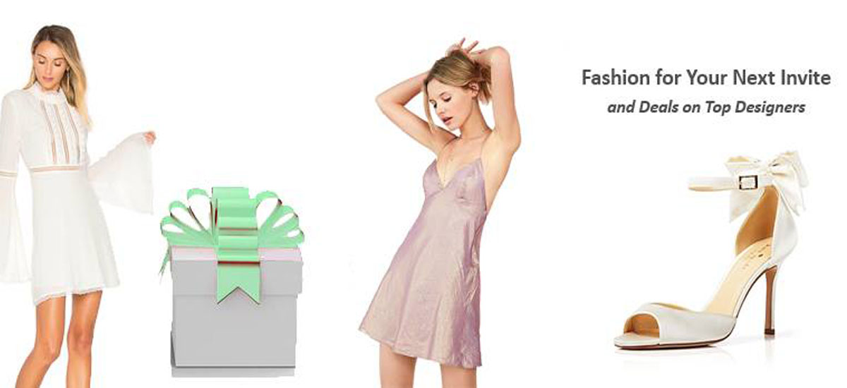
We’ve researched and featured the latest trends in women’s clothing & accessories. Numerous products are added each week helping you keep track of the most fabulous women’s fashion available; items include but are not limited to: women’s clothing items; women’s accessories; featured top designers, clothing lines, and stores such as: AQUA, Majorelle, Specialty Boutiques, LOFT, Ann Taylor, Bloomingdale’s, BCBGMAXAZRIA, French Connection, ADRIANNA PAPELL, free people, ONE by Contrarian, BADGLEY MISCHKA, Monique Lhuillier, Edun, House of Harlow, Betsey Johnson, Laundry, francesca’s and more; written articles specific to featured fashion items helping you stay informed on the latest trends in women’s wear; and one consolidated place to access all exclusive sale codes (as much as 80% OFF!) for top designers and top stores including: LOFT, Ann Taylor, Nordstrom, Bloomingdale’s, GUESS, Kohl’s, Stuart Weitzman, Forever 21, Lord & Taylor, BCBGMAXAZRIA and More – including exclusive sale codes for Black Friday! Join our mailing list – enter your email on our site – to receive updates on the latest fashion sale codes.
Looking fabulous while saving is possible right at your fingertips using the Fashion & Invites blog. Prefer looking at the fashion and deals through an app? The Fashion & Invites-Women’s Wear App is available exclusively at the Google Play Store at the following link: (https://play.google.com/store/apps/details?id=com.kazy.luxewebview&hl=en). Happy shopping and happy saving!
Fashion for Your Next Big Invite!
Contact-Details: Fashion & Invites, Brig Marie, Ocean Ave Long Branch NJ, support@showermewithinvites,com, http://www.fashionandinvites.com

Press release distributed via EPR Network (http://express-press-release.net/submit-press-release.php)

